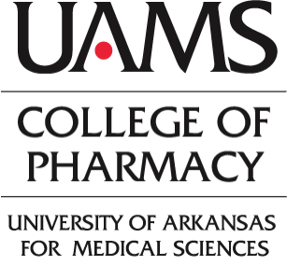
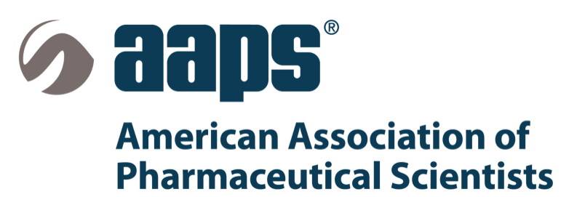
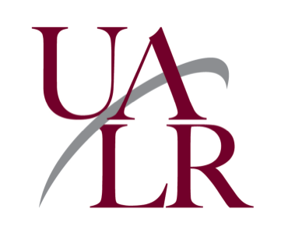
DRUG DISCOVERY AND DEVELOPMENT COLLOQUIUM 2014
June 20 – 21, 2014
UAMS Campus, Little Rock, Arkansas

Registration Form

Registration Information: Early registration ends May 27, 2014. Please register prior to the deadline to aid meal planning by the organization committee. Please return one registration form per participant with the registration fee. This fee includes the use of facilities, a copy of the proceedings, meals and admission to related events.
Faculty | USD $80 ($100 after May 27th )
Student | USD $40 ($50 after May 27th) (Registration will be covered for presenting students whose abstracts are accepted for presentation)
Post-doctoral Fellow | USD $40 ($50 after May 27th)
Guest | USD $15 ($20 after May 27th) (Please add this amount to your registration fee if you plan to bring a guest to the mixer and/or reception)

Title ______ First Name _________________ Middle Initial ____ Last Name_______________
Faculty _____ Student _____ Post-doctor _____ Guest _____
Organization/University/Company_______________________________________
Business Address (street) _____________________________________________
City __________________State _______________Zip _____________
Business Phone ____________________Fax___________________ E-mail ________________________
Business web site ___________________________________________________
Vegetarian meal requested Yes _____ No _____

Payment:
Check for $___________ payable to “DDDC14” in U.S. dollars and drawn on a U.S. bank

Address for sending the registration form and check | For on site registration (cash or check only)
UAMS-Department of Pharmaceutical Sciences  Kim Tarkington  4301 W. Markham St., Slot 522-3  Little Rock, AR 72205  Email: TarkingtonKimberlyD@uams.edu | University of Arkansas for Medical Sciences  I. Dodd Wilson Education Building  4301 W. Markham St.  Little Rock, AR 72205  T: (501) 686-7159  http://www.uamshealth.com/mapsanddirections
Inquires about registration: e-mail Shraddha Thakkar at DDDC2014@gmail.com
Cancellation Policy: A 75% refund will be issued if the cancellation is received by the DDDC’14 in writing no later than June 10, 2014. No refunds will be issued for cancellations received after that date; however, with advance notice, you may transfer your registration to a colleague.

