SAM 2016
Student Registration Instructions
(Temporary Account for Testing)

- Go to http://sam.cengage.com/Login to set up your account, click on “New User.” In the future you will use this link to return to SAM and enter the username/password created in the steps below to Log In.
- Enter the Institution Key (T2026598) and click Submit. It will ask you to confirm that you have the correct iKey. Click Ok.
- When asked to enter the 18-digit SAM Access Code, select “Enter Later”—you will be given temporary access (2 week) during which you can take the competency exam multiple times if needed to reach the passing score of 70%.

- The MY PROFILE page will display, enter your profile information and click Save. NOTE: If you already have a SAM account, you will receive a note that the user already has an account. If you receive this message, go to step 6 to enter CengageBrain.
- If you do NOT have an existing CengageBrain account, refer to step number 7 below (NOTE: the SAM username/password you have created will also create a CengageBrain account for you to use in the future).
- If you DO have an existing CengageBrain account the following screen will appear. (Your CengageBrain account may have been used to purchase Cengage Learning products as well as access other Cengage Learning technologies such as CengageNOW, CourseMate or Aplia.)
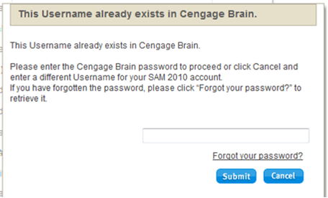
  - If you know your CengageBrain password, enter it and click submit. Refer to step 7.
  - If you do NOT know your CengageBrain password, clicked on the ”Forgot your password?” link
    - You will be taken to the CengageBrain Retrieve Password page. Entered the email address used to establish your SAM account and answer the security question
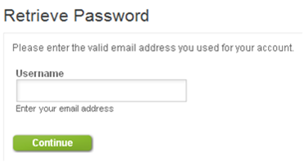
    - You will be directed to check your email. There you will find a message from CengageBrain with a link in it to reset your password.
    - The link above will take you to a Reset Password page where you can enter a new password (it will opened your CengageBrain homepage – you can close this)
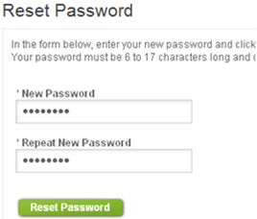

    - Go to the SAM page where this box that appeared in Step 6 should still be open, enter the password you just reset in CengageBrain and click Submit.
- Review the Terms & Conditions and click “I Agree”
- In the middle of the SAM homepage, click on “Sections”
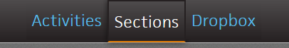

- Click on Join a Section (you may need to click the “x” in top right corner of the blue “Instruction link . . . ” overlay if it appears) and then use the dropdown box to filter the sections by the instructor name Mitchell, Robert. Carefully, select the IT Competency Exam 2018 section by clicking on the Join Section icon to the far right of the section name.
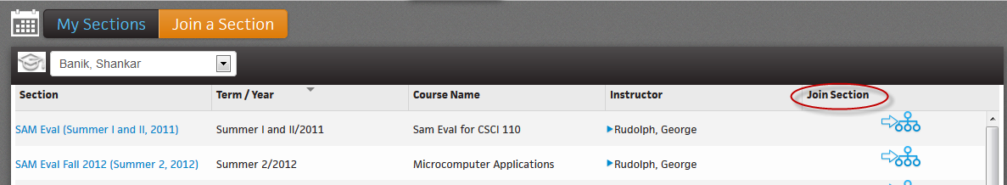

- Go to the Activities link at top of screen and then click Activity List where you can access the IT Competency Exam 2018.
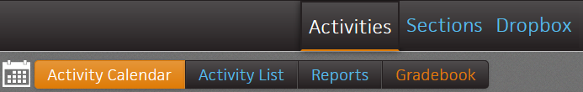

- This exam is password protected. You can log off the system.
- You are now ready to take the exam using one of the identified methods through the UALR Testing Center.

