FFTA: User Reference Guide
UALR Foundation Funds Tracking and Administration

Login: ffta.ualr.edu
Email: ffta@ualr.edu
Sarah C.Travis
Revised: 10/8/2013
Original: 6/21/2013
Visit: ualr.edu/development/ffta

Contents
What is FFTA? 4
Navigation 4
Login and Logout 4
User Profile 4
Vacation Leave 4
Email Notifications 5
View Accounts 5
View Account Details 6
Uploaded Documents Error! Bookmark not defined.
Show PAR Documents Error! Bookmark not defined.
Account Actions 7
Payment Request Form 7
Change Authorized Account Signer 7
Change Account Name 7
Create a Payment Authorization Request (PAR) 8
Add Vendor 8
Request New Vendor 8
Check Memo 9
Special Handling 9
Taxable Payments 9
Charge Information 9
Upload Backup Documentation 9
Save and Submit PAR for Approval 10
View PARs 10
Update PARs 10
Print PARs 11
Search 11
Approve and Deny Requests 11
View Reports 12
Submit Feedback 13
Appendix A: Use and Confidentiality Agreement 14
Appendix B: Contact Information 15
Appendix C: Personal Reimbursement Policy 16
Appendix D: Allowable Tip Policy 17
Appendix E: Allowable Unrestricted Expenses and Reimbursements Using Unrestricted Funds Policy 18

What is FFTA?
FFTA is an online payment authorization application that facilitates the Foundation payment authorization request process and stores Foundation account information and supporting documentation.

Navigation

Login and Logout
You can log into the FFTA system at ualr.edu/development/ffta using your NetID. If you do not know your NetID or need to reset your password, log into boss.ualr.edu.
Log out at any time by clicking the Logout link on the left navigation list.

User Profile
You can view your user profile information at any time by clicking the My Profile link next to your name on the left navigation list. Here you will see:
- Your NetID login
- Full name
- Title
- Email
- Phone number
You can update any of these fields as needed by filling out the new information and clicking the Update button at the bottom of the form.

Vacation Leave
If you will be unable to approve PARs for a period of time, you can use Vacation Mode to activate proxy rights if you have a proxy designated.
To enter Vacation Mode:
- Click on My Profile to view your User Profile.
- Click Turn On under the Vacation Mode menu bar. You will then be reminded of your delegate users who will have proxy rights while you are in Vacation Mode.
To leave Vacation Mode:
- Click on My Profile.
- Click Turn Off under the Vacation Mode menu bar. Proxy roles will be deactivated.
Note: If you do not set Vacation Mode to On and are unavailable to approve PARs, all PARs requiring your approval will be delayed until Vacation Mode is turned On allowing a proxy to approve.

Default Role
Some users will require more than one role. If you have more than one role, you can select which role you want to use each time you log into FFTA.
To set your default role:
- Choose your role from the Default Role drop-down menu.
- Click Save to set your default role.

Email Notifications
By default, you will receive an email notification whenever a PAR has been submitted that requires your approval or a question has been asked or answered about your PAR. You can turn these notifications on or off by updating your profile.
- Click on My Profile to view your User Profile.
- Click Turn Off (or Turn On) under the Email Notifications menu bar.
Note: If you turn off email notifications, you will need to sign into the FFTA application to view pending PARs.

View Accounts
You are authorized to view all accounts in your department or division. View your accounts at any time by clicking the View Accounts link on the left navigation list.
Filter or sort the list of accounts using the View and Order By drop-down menus at the top of the screen. Click the Refresh button to see your changes. You can click the Save as default VIEW button to keep your changes for the next time you go to View Accounts.
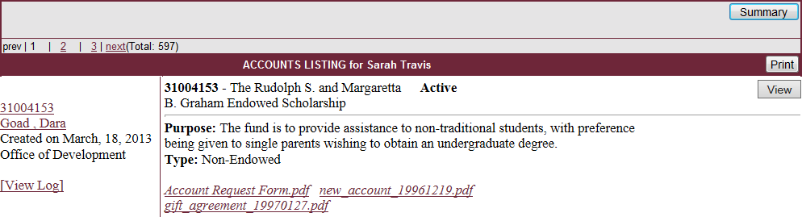
Export your list of accounts by clicking the Summary button at the top right of the Accounts Listing form. This will give you the option to open or save an Excel file with account summary information.
For each account, you can click the hyperlinks to the left of the Purpose description to view more information:
- Clicking the account number will take you to the Detailed Account View. You can view the same information by clicking the View button at the top right of the account summary.
- Clicking the contact name allows you to send an email to that person.
- Clicking View Log will show you the account history including when it was created, updated, and by whom.

View Account Details
To view account details, click the account number link to the left of the account information or click the View button to the top right.
The Detailed Account View displays the following information:
- Account name, number, associated department/division, type, purpose, and initial deposit amount
- Current balance (updated daily at 11:00 AM)
- Associated account forms and Gift Agreement (where available)
- Account contact and signers [click the Details > > link for more information]
- Uploaded Documents including new account, gift agreement, and signer forms (where available)

Submitted Forms
If there have been any forms submitted for the account such as a Payment Authorization Request, Change Signer, Transfer Request, etc. they will be listed under the Submitted Forms section of the Detailed Account View. Here you can:
- View form log
- Ask a question about a form
- See date submitted and status
- View PDF form
- Update a PAR
- Sign-off or approve a PAR
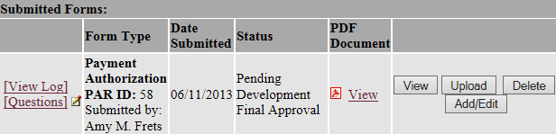

Account Actions
While viewing account details, you can request any number of actions from the Select Action drop-down menu:
- Payment Request Form - Create Payment Authorization Request
- Change Signer Form - Change Authorized Account Signer
- Change Account Name – Change the name of the account
- Close Account Form – Close the account
- Change Account Contact – Change the employee contact information
All forms, except the Payment Request Form, will be sent directly to the Development office for approval.

Payment Request Form
See following section titled Create a Payment Authorization Request (PAR).

Change Authorized Account Signer
To change the Account Signer for an account:
- Locate that account and choose Change Signer Form from the Select Action drop-down menu.
- Click Go.
- On the Change Authorized Account Signer Form, click the Add Signer link.
- Search for the new signer’s name.
- Click the Add link next to the name of the new signer.
- To remove a signer, click the Remove link to the right of the signer’s row.
The changes you have requested will be sent via email to the Development Office for approval.

Change Account Name
To change the Account Name for an account:
- Locate that account and choose Change Account Name from the Select Action drop-down menu.
- Click Go.
- Fill out the new account name in the Change Account Name to field.
- If the quarterly earnings distribution needs modification, enter those instructions in the next field.
- Click Submit Changes.
The changes you have requested will be sent via email to the Development Office for approval.

Close Account
To begin the process of closing an account:
- Chose the Close Account form from the Select Action drop-down menu.
- Click Go.
- Fill out the Reason for closing account field.
- Enter account name and number to where remaining funds will be transferred (if applicable).

Create a Payment Authorization Request (PAR)
To request reimbursement from a Foundation-held account, you must complete a Payment Authorization Request.
- Locate the account either by clicking View Accounts to see your list of accounts or using the Search option located in the left navigation list.
- Click the Account Number to view the Account Information.
- Review the Account Purpose to ensure your request will not violate the terms of the account.
- Check the Balance shown for sufficient funds for your request.
(Note: Balances are updated by 11am.)
- Choose Payment Request Form from the Select Action drop-down menu on the top menu bar. Click Go.

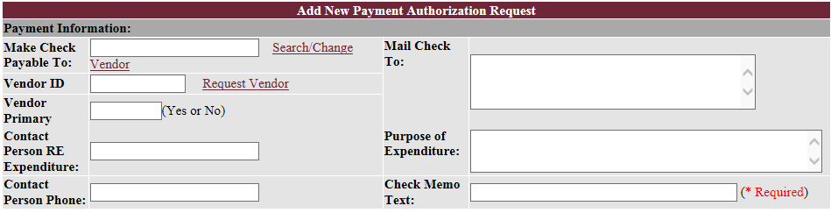

Add Vendor
- Click Search/Change Vendor to select the vendor being reimbursed.
- Fill out part or all of the vendor name in the text field and click the Search button.
Note: You can also search by partial FOPAL number.
- Check that the address of the vendor is correct. If it is not, click the Change link to the right of the vendor information. Fill out the new information and click the Send button. If the address is correct, click the Select link to the right of the vendor information.
- The Mail Check To text box, Vendor ID field, Vendor Primary field, Contact Person RE Expenditure field, and Contact Person Phone will be populated based on the vendor chosen.

Request New Vendor
If you are requesting reimbursement to a vendor that is not listed in the Vendor list, you will need to request it be added.
- Click the Request Vendor link on the Add New Payment Authorization Request form or on the left navigation list.
- Fill out the Vendor Request form with contact information.
Note: Vendor requests must be completed by 3:00 PM for the new vendor to be available on the vendor list the next business day. Inaccurate information on this form will delay payment reimbursements.

Check Memo
The Check Memo Text field is required and will display on the check memo line. Include any invoice number or other identifiable information for the vendor in this field.

Special Handling
If needed, choose the appropriate special handling option.
Note: If either Fed-Ex option is chosen, the account from which you are requesting reimbursement will be charged the Fed-Ex fee.

Taxable Payments
When a payment authorization is for services rendered, the fields in the Required Information for Taxable Payments section must be completed.
Note: If the check is payable to a current employee or student, please contact the Office of Development for additional information.

Charge Information
You will need to add a charge for each invoice and each expenditure code.
- Click the Add Charge button. The account number and account name from which the payment is being requested are prepopulated.
- Fill in the payment Amount field, and select the appropriate expenditure code from the Exp. Code drop-down menu.
(Note: If you are unsure which expenditure code to use, click the question mark icon to the right of the drop-down menu for a description of each code.)
- If you have an invoice, fill out the Invoice No. and Invoice Date fields. If you do not have an invoice, leave the current date in the Invoice Date field.
- Click the Add button. This will populate the Total Check Amount field.
- Repeat for any additional expenditure codes or invoices.
You can edit or delete existing charges using the pencil and trashcan icons to the right of the charge.

Upload Backup Documentation
Complete documentation is required for accurate and timely reimbursements. Scan any receipts or proof of payment, attendee or recipient lists, invoices to a PDF file.
Note: For more information on supporting documentation and related policy, please see Appendix C: Backup Documentation Policy.
- Find the Documents section at the bottom of the Add New Payment Authorization Request form.
- Choose a document type from the Select Document Type drop-down menu.
- Click Choose File and browse to the file you want to upload. Click the Add button.
- Repeat for each additional piece of documentation.

Save and Submit PAR for Approval
Click Save at any time to save the PAR. When the PAR is complete and documentation is uploaded, click Submit to finalize the PAR. The PAR will then appear in the queue of the next approver.

View PARs
To view only PARs, click View PARs on the left navigation list. Filter or sort the list of PARs using the View and Order By drop-down menus at the top of the screen. Click the Refresh button to see your changes.
For each PAR, you can click the hyperlinks to the left of the Account and Purpose description to view more information:
- Clicking the PAR number will take you to the Detailed PAR View.
- Clicking the account number will take you to the Detailed Account View.
- Clicking the contact name allows you to send an email to that person.
- Clicking View Log will show you the account history including when it was created, updated, and by whom.
PARs are also visible in the Account Listing at the top right of the associated account. The color-coded legend at the top of the form explains the PAR status colors.
* The PAR in OLIVE means it has been saved but hasn't been submitted, and you have rights to submit this PAR.
* The PAR in GREY means it is in the SAVED status, and you don't have rights to signoff.
* The PAR in GREEN means it is pending on your approval.
* The PAR in RED means it is not in your queue, but it's pending on someone else's action.
To view pending PAR details, click on the PAR form number in the account listing.
While looking at a submitted PAR, you can direct a question to the Development office by clicking Questions at the top of the PAR page.

Update PARs
- Find the PAR in the View PAR list or the account in the View Accounts list.
- Click on the account number.
- Find the saved PAR under the Submitted Forms section.
- Click Add/Edit to the right of the PAR.

Print PARs
To print a PAR:
- Locate it by clicking View PARs or Search.
- Click Print at the right of the top or bottom PAR Listing menu bars.

Search
To locate a specific account or PAR, click Search on the left navigation. If there is only one account matching your criteria, you will be directed to Detailed Account View screen for that account.
Search tips:
- Hold down CTRL key to select multiple account types or account statuses.
- Account Number refers to the number assigned by the UA Foundation Office.
- FFTA Number refers to the temporary number assigned by FFTA System.

Approve and Deny Requests
After a payment authorization has been submitted by an initiator, the FFTA system passes it through an approval chain beginning with the account signatory and ending with final approval at the VCFA office. Once you have approved or denied a PAR, it will no longer show in your pending list.
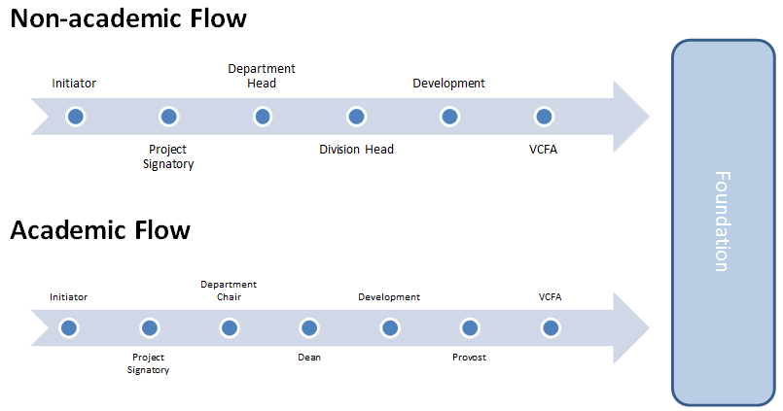
Payment Authorization Approval Chain

To view PARs needing approval:
- Log in or click View Accounts.
- Choose All PAR Forms Waiting for Your Review from the View drop-down menu at the top of the screen.
- Click Refresh to show your list of PARs.
Note: If you have no PAR forms waiting for your review, the screen will refresh to show all accounts.
- Click the PAR form number to review the PAR information.
- If you have a question about a PAR, click Questions at the top of the page. This will send an email to the Development office and place a note on the PAR summary showing that a question has been asked.
- After reviewing the PAR information, click the Approve or Deny button at the bottom of the page.
- If the PAR is being denied, fill out the Notes text box with the reason for denial. This will return the PAR to the initiator.
Note: If you are both the Account Signatory and a Department Chair, you will be asked if you would like to sign off as the next approver.

View Reports
Chair and department heads can view a department-level report showing the number of completed PARs submitted by month. To view this report, click PAR Summary on the left navigation list.
Dean and division heads can view the PAR Summary as well as additional college-level or division-level PAR Reports:
- Mailed PARs – lists mailed date, vendor, department, amount, and account name and number for all PARS mailed to the Foundation. Limit by date range by updating the From and To fields. Click Refresh to see the results. Click the Download Excel button to export the list to an Excel spreadsheet.
- All PARs – lists the creation date, purpose, amount, account number, status, and department associated with all completed PARs. You can sort this list using the Sort by drop-down menu and choosing Ascending or Descending in the second drop-down menu. Click Submit to see your changes. Click the Export to Excel link to export the list to an Excel spreadsheet.
- User Reports – shows number of actions and average time spent on PARs by user, department, or role type. This report is accessed by clicking the User Reports link on the left navigation list. To limit the report by department, choose a department in the Department drop-down menu at the top of the page. Click Refresh to see your changes.
- User List – lists all users by department, associated roles and accounts. This report is accessed by clicking the User List on the left navigation list. Click a name to see individual time summaries.

Submit Feedback
The Development office welcomes any and all feedback from FFTA users. Please email ffta@ualr.edu with your questions, concerns, suggestions, etc.

“It has been a huge improvement with widely noted gains in both processing and reimbursement
time.”
-Lora Witt, UAMS Pediatrics

“I’ve been processing payments through the U of A Foundation system for 20+ years. The current system is the best yet!! What a pleasure to use and so much faster and more efficient.”
-Joe Cook, Jack T. Stephens Spine Institute

“I really like that all the information about the fund will be easily accessible. This will be so much easier and convenient for all those involved in the payment authorization process from originator to the final approver. I love the reduction of paperwork as well. We cannot wait to go live.”
-Laura Webb, UALR College of Business

Appendix A: Use and Confidentiality Agreement

Foundation Funds Transfer Administration (FFTA)
Use and Confidentiality Agreement

Records stored in and processed through the FFTA system may contain confidential, proprietary and privileged information. Unauthorized disclosure or use is prohibited. To maintain the integrity of the information contained in the FFTA system, users will adhere to applicable federal and state laws regarding privacy as well as maintain the guidelines listed below.

Unauthorized use of information in files maintained, stored, controlled, or processed in the FFTA system is strictly prohibited.

Seeking personal benefit, allowing or aiding others to benefit personally or to divulge, in any way, knowledge of any confidential information that has been obtained in the scope of employment is prohibited.

Exhibiting or divulging the contents of any record or report to any person except in the scope of employment and in accordance with applicable policies and procedures is prohibited.

Knowingly including or cause to be included, false, inaccurate, or misleading information is prohibited.

Every person is responsible for his or her assigned user-ID and password and these are not to be shared with anyone else. No one shall use another person's user-ID and password.

Any violation or knowledge of a violation of this code will immediately be reported to the employee's supervisor and may lead to account suspension and further disciplinary action by UALR.

Appendix B: Contact Information

- FFTA contact email: ffta@ualr.edu
- Chris Hamilton, Director of Accounting
clhamilton@ualr.edu, 501.683.1484

Appendix C: Personal Reimbursement Policy

Reimbursement of out-of-pocket purchases, which are not incurred as part of authorized travel, may be requested. Reimbursement can be made only to employees of the University.
Required documentation: a completed, signed payment authorization form; vendor produced invoice reflecting a zero balance due; and employee proof of payment.

The UALR Purchasing / Procurement Policy Page 13
Arkansas State Statutes 19-11-201 thru 1206; 91-4-1206;
15-4-301 thru 820; 22-8-101 thru 104; 23-61-601 thru 610
February 11, 2013

Appendix D: Allowable Tip Policy

Based on Arkansas Annotated code #19-4-904, prescribed by the Arkansas Financial Management Guide published by the Office of Accounting of the Department of Finance and Administration and related policies and procedures currently being adhered to at the University of Arkansas at Little Rock, the allowable tip reimbursement amount through the UALR Foundation shall not exceed fifteen percent (15%) of the meal amount expended.
Limited exceptions may be made when mandatory tips are charged for large groups and printed on the receipt by the business. In this case, additional tips may be reimbursed.
Required documentation: a completed, signed payment authorization form; vendor produced invoice reflecting a zero balance due; and employee proof of payment.

Arkansas Department of Finance and Administration
Travel Regulations
Arkansas Annotated code #19-4-904
February 11, 2013

Appendix E: Allowable Unrestricted Expenses and Reimbursements Using Unrestricted Funds Policy

The purpose of this policy is to ensure that all expenditures of private donations and revenue enhance the educational mission of the University of Arkansas at Little Rock.
Unrestricted funds can originate from unrestricted charitable contributions, membership fees and various sources of auxiliary revenue. Proceeds from the sale of non-cash gifts can also be unrestricted funds. Unrestricted funds, often called discretionary funds, are subject to the stewardship of the Office of Development and are used for the purpose of enhancing the university’s educational mission, goals, and objectives. A donor may make an unrestricted donation to the university, but prescribe at whose discretion (the Chancellor, a faculty member, etc.) the funds are to be spent. Such funds are still considered to be unrestricted and are subject to established guidelines and approvals.
Expenditures from all privately funded, discretionary accounts are limited to those that promote the educational mission and objectives of the University of Arkansas at Little Rock and the UALR Foundation and in no way should create or cause direct or personal benefit to an individual or group.
If you have any questions or concerns regarding your reimbursement, please contact the Director of Compliance and Donor Relations at 501.569.3249 or labennett@ualr.edu.

UA System Board of Trustees Policy - 260.1
Official Functions Policy 9.19.02
May 8, 2013

