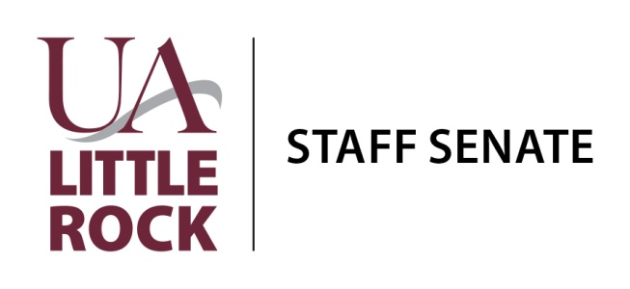

March 15, 2018
Student Services Center—Donaldson Auditorium (Room 104)
10:00 a.m. – 11:00 a.m.

- Welcome and Introductions
- Review Minutes
- Treasurer’s Report
- Committee Updates

  - Blood Drive
  - Communications
  - Fundraising
  - Governance
  - Helping Hands
  - Issues and Concerns
  - Professional Development
  - Staff Awards Ceremony

- Ad Hoc/University Committees

  - Campus Beautification
  - University Budget
  - HLC/Accreditation
  - Policy Advisory
  - Social Engagement

- Open Forum
  - Discussion on Nonclassified Performance Evaluations
  - “Heart of A Trojan” Campaign
  - Out of Darkness Suicide Prevention Staff Senate Walk Team
  - Staff Engagement, Mission and Vision for the Future
  - Volunteer Opportunity—April 19, 2018

- Next Meeting—April 20, 2018 (2018 Staff Awards Ceremony)
- Adjourn

