
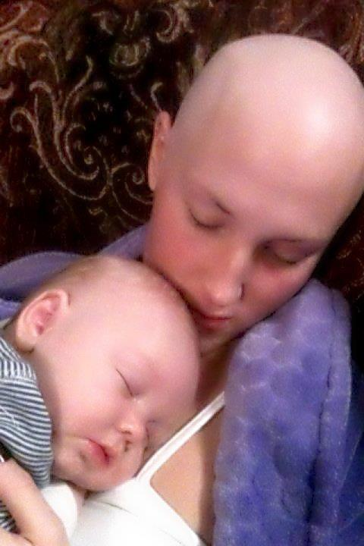

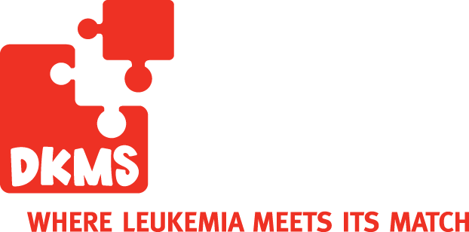
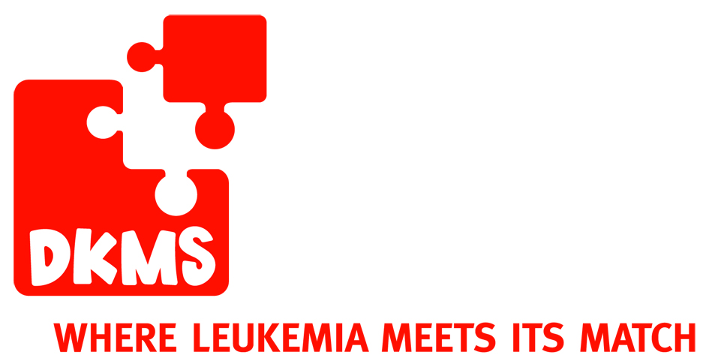
Volunteer Opportunity! Help Save this Mother’s Life at UALR!
UALR Staff Senate Donor Drive Thursday, February 23rd

Leslie Harris was diagnosed with leukemia (AML) on Wednesday, September 21st just hours before giving birth to her beautiful baby boy Samuel Ayden. Her prognosis is grim, but we believe in the presence of miracles! Leslie has started her second round of chemo and has had a very long couple of months of sickness, surgery and pain. She says she only has 6 months to a year to live without a transplant but she's going to spend every moment fighting for her life and her son. She desperately needs to find a bone marrow donor.

Please help continue our fight for Leslie and other leukemia patients by attending the UALR Staff Senate Donor Drive February 23rd or by volunteering to help run a bone marrow donor drive to find donor matches.

Contact Amy Britt
ABbritt@aol.com
501-607-3009

www.GetSwabbed.org
BECOME A LIFESAVER!
Become a volunteer!
You will receive credit for community service hours and a letter of recommendation!

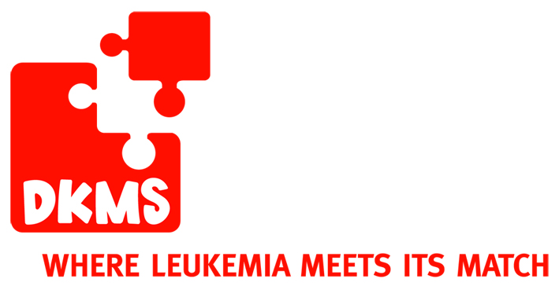
IMPORTANT FACTS YOU NEED TO KNOW
ABOUT BONE MARROW DONATION.
Why bone marrow donation is so important.

The DKMS mission is to save lives by recruiting bone marrow donors for patients with leukemia and other blood diseases. With over 2.8 million potential donors worldwide, DKMS is the world’s largest bone marrow donor center. Even so, 6 out of 10 patients never receive the lifesaving transplant they need.

YOU are important as a bone marrow donor because every new donor increases the chance that a patient will find the lifesaving match they need. The donor and patient must have at least 8 tissue (HLA) characteristics in common to be considered a match but ideally should have 10. With more than 4000 known characteristics that can occur in millions of combinations, finding a match is extremely difficult. This is why every new donor counts!

How do I register as a bone marrow donor? You must be 18 to 55 years old, in good general health, weigh at least 110 pounds, but not exceed a body mass index of 40, and be willing to donate to any patient in need. If you meet these requirements, you will be asked to complete a registration form and swab the inside of your cheeks to collect cells for HLA tissue typing.

What is my commitment? Your information will be listed anonymously on the Be The Match Registry® (operated by the NMDP) until your 61st birthday. You must be willing to consider donating to any patient who needs you. You must keep your contact information updated in the DKMS database at all times.

What is the donation process like? If you are a match for a patient, a DKMS representative will contact you. You will fill out a health questionnaire, and if all is well, undergo additional testing. If you are found to be the best possible donor, you will donate in one 1 of 2 ways. Cells are collected from either your bloodstream or the back of your pelvic bone. The donation method is determined by the patient’s doctor.

- Peripheral Blood Stem Cell Donation
  - Cells are collected via the donor’s bloodstream.
  - To increase the number of stem cells in the bloodstream, the donor receives daily injections of a synthetic protein
called filgrastim for 4 days before, and on the day of the collection.
  - During the collection, blood is removed with a sterile needle from one arm, and passed through a machine that separates out the blood stem cells. The remaining blood is returned to the donor through the other arm.
  - The cell collection is a non-surgical, outpatient procedure that takes about 4-6 hours on 1-2 consecutive days.
  - While taking filgrastim many donors experience flu-like symptoms, such as headaches bone and muscle achiness and fatigue. Most side effects subside within 48 hours of donating.

- Bone Marrow Donation
  - Marrow cells are collected from the backside of the pelvic bone (not the spine) using a special syringe.
  - Donors receive general anesthesia so no pain is experienced during the marrow extraction.
  - This is a 1-2 hour, outpatient surgical procedure. Most donors are discharged from the hospital at the end
of the day.
  - Many donors experience some pain, bruising, and stiffness for up to two weeks after their donation. Within a week of donating, most donors are able to return to work school and most regular activities. The donor’s marrow completely replenishes within a few weeks.

More Ways You Can Help:
• Help us finance the $65* donor registration cost. Make a monetary donation at www.GetSwabbed.org.

• Organize a donor drive in your community, or at your office or school.

• Encourage friends and family to register with DKMS at a drive, or online at www.GetSwabbed.org.

• Join us on Facebook and follow us on Twitter. Search “DKMS Americas” to find our page.

• Fundraise for DKMS. Set up a fundraising page at FirstGiving.com/DKMS.

• Go to our website to learn even more ways you can help. Visit www.GetSwabbed.org.

*DKMS never requires new donors to pay the registration costs. This is why we urgently need monetary donations to further expand the DKMS donor
database. 100% of every financial contribution is used to register new, potential donors. DKMS Americas is a 501 (c)(3) non profit organization.

DKMS• 33 E 33rd Street • Suite 501 • New York, NY 10016 • T: 866.340.DKMS (3567) • F: 212.209.6798 • info@dkmsamericas.org

