2017 UALR
CARNIVAL OF CLUBS
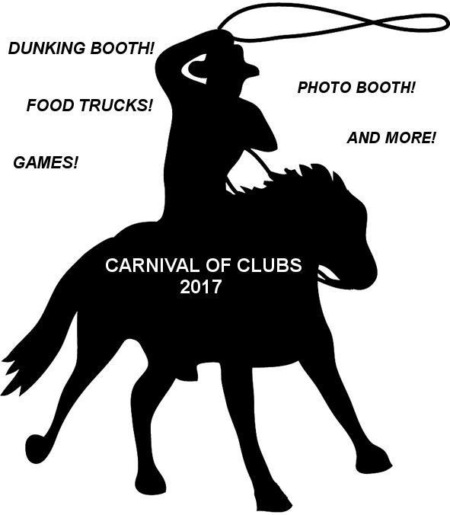
Tuesday, AUGUST 29 (9am-1pm)
At the College of Business (Reynolds Building)
Meet students and join student groups! Sign up for study abroad trips! Learn about business programs!
And many other opportunities!

