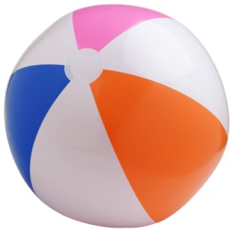Bongo Ball
4-5-10
Attendance: 27 Males
5 Females

