“IFC Chapter Recruitment Survey”
Interfraternity Evaluation
Office of Campus Life, UALR

On Friday, September 14, 2007 and Saturday, September 15, 2007, IFC Fraternity Formal Recruitment was held in the University Commons Great Room. Chapter members were asked to complete a survey to rate various aspects of the process, with 5 being the most accurate. The results follow:

Question #1
Ethical Conduct throughout recruitment.

Rating 1 | 0
Rating 2 | 0
Rating 3 | 9
Rating 4 | 14
Rating 5 | 14
Total Responses | 37

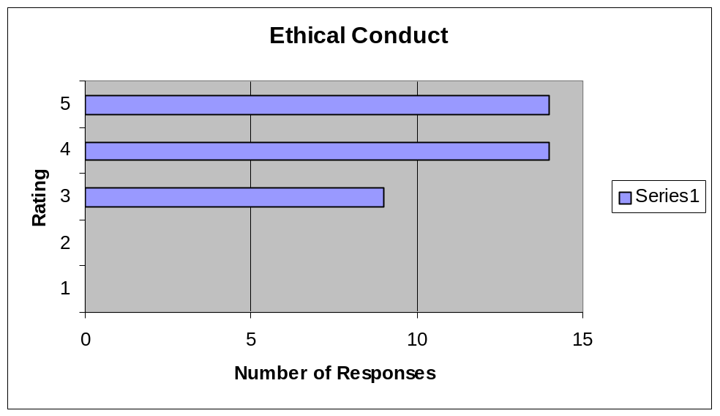

Marketing:

Question #2
Overall marketing of fraternities.

Rating 1 | 4
Rating 2 | 11
Rating 3 | 7
Rating 4 | 13
Rating 5 | 4
Total Responses | 39

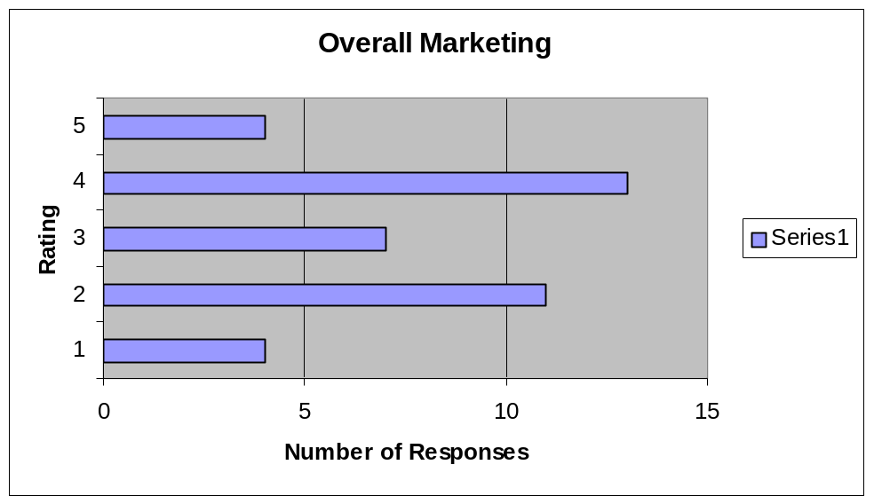

Question #3
Recruitment marketing to new students.

Rating 1 | 3
Rating 2 | 10
Rating 3 | 11
Rating 4 | 12
Rating 5 | 3
Total Responses | 39
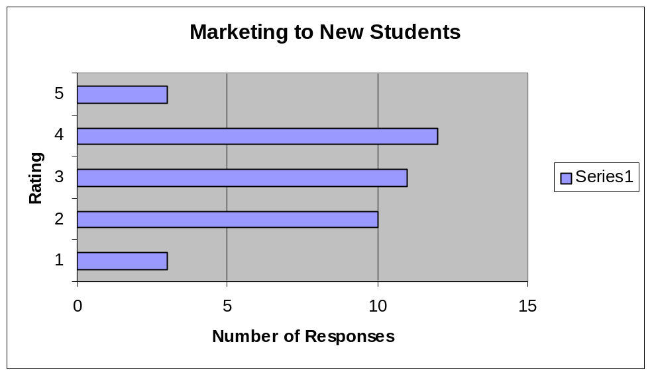

Question # 4
Recruitment marketing to returning students.

Rating 1 | 10
Rating 2 | 7
Rating 3 | 12
Rating 4 | 8
Rating 5 | 2
Total Responses | 39

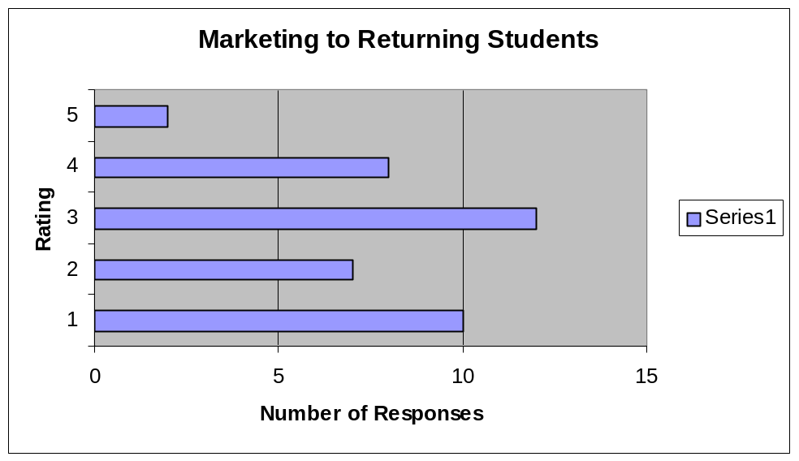

Suggestions for Marketing:
- I am neither a new student or returning student.
- More Advertisement.
- E-mails to eligible students 2 weeks prior to rush.
- Advertise more; get the options to rush out there more.
- Greek Life should be portrayed as “the thing to do.”

Recruitment Schedule:

Question # 5
Dates worked well.
Rating 1 | 1
Rating 2 | 3
Rating 3 | 14
Rating 4 | 12
Rating 5 | 9
Total Responses | 39

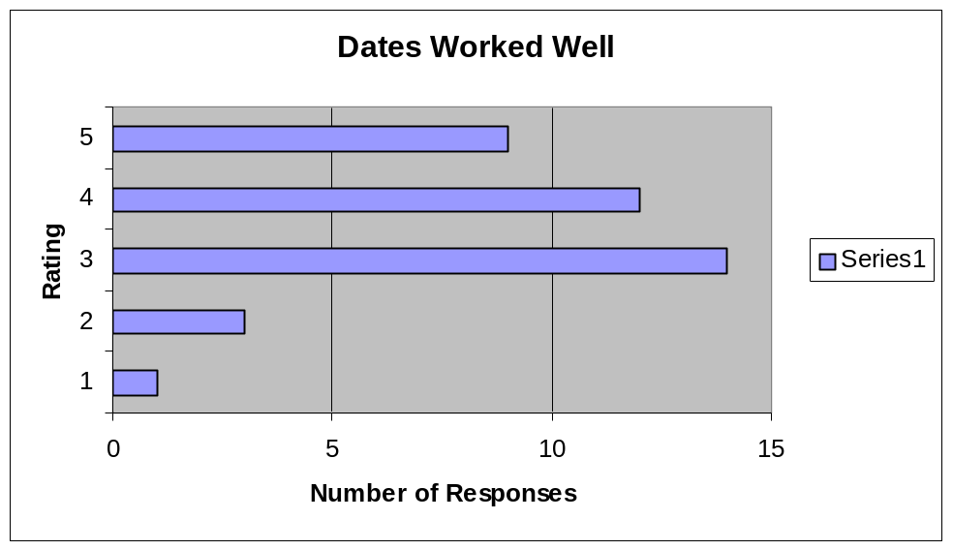

Question # 6
Too late in the semester.
Rating 1 | 11
Rating 2 | 13
Rating 3 | 10
Rating 4 | 2
Rating 5 | 3
Total Responses | 39
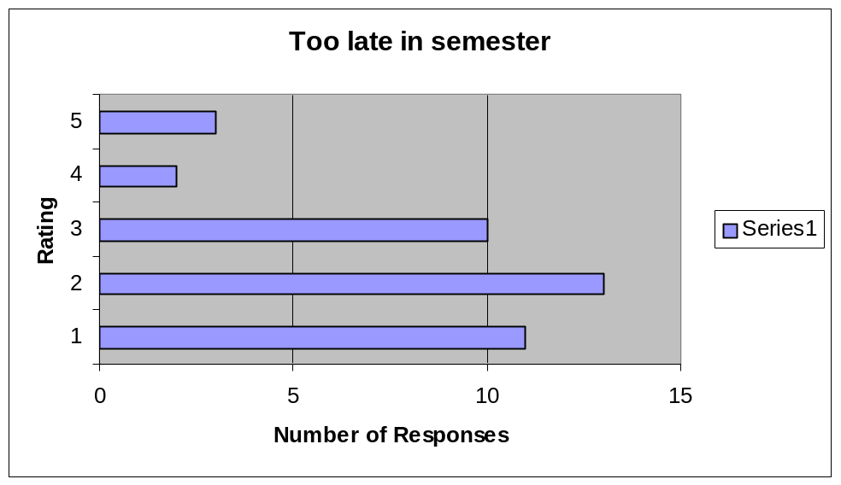

Question #7
Event times worked well.

Rating 1 | 0
Rating 2 | 5
Rating 3 | 13
Rating 4 | 12
Rating 5 | 9
Total Responses | 39

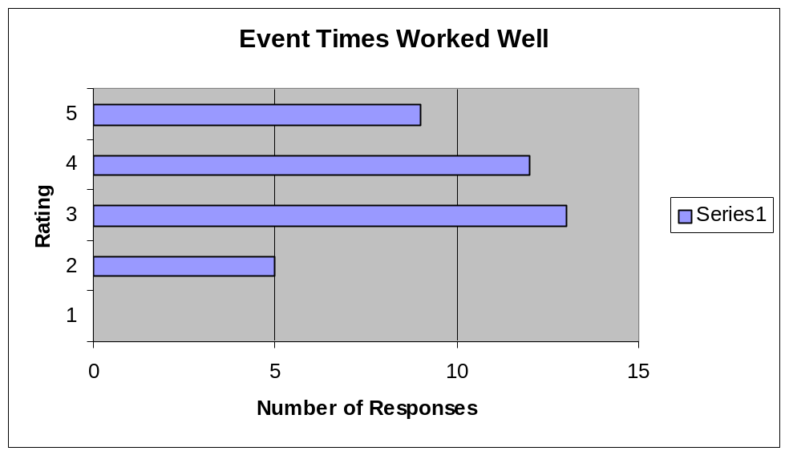

Recruitment Style

Question # 8
Formal Recruitment works well at this institution.
Rating 1 | 13
Rating 2 | 4
Rating 3 | 6
Rating 4 | 7
Rating 5 | 9
Total Responses | 39

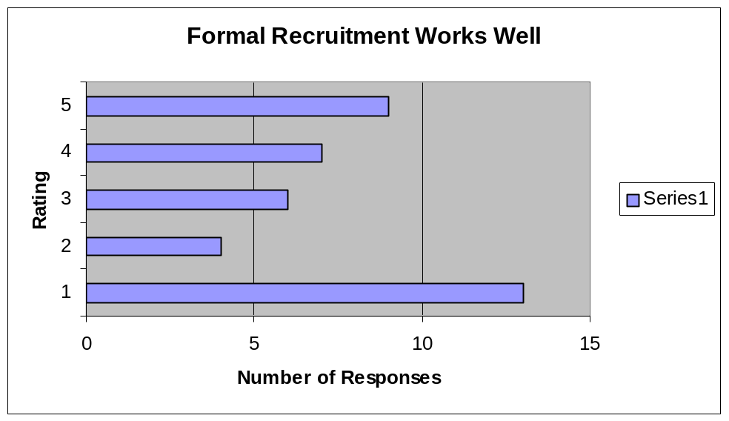

Question # 9
Potential New Members enjoy Formal Recruitment.
Rating 1 | 9
Rating 2 | 5
Rating 3 | 9
Rating 4 | 8
Rating 5 | 8
Total Responses | 39

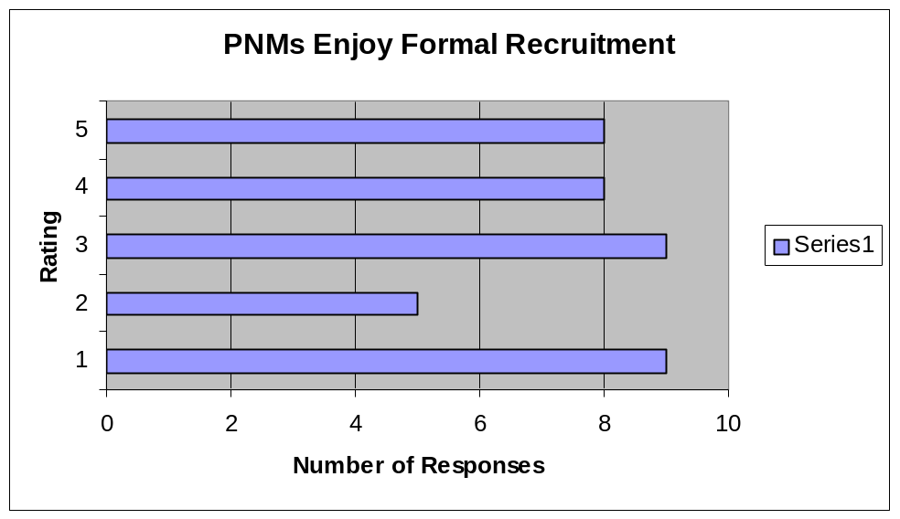

Comments:
- This is confusing.
- Formal Rush is a positive aspect to the Greek system at UALR.
- Make sure all new members go through formal.
- Didn’t start on time.
- We are the shit.
- I believe formal is a valuable tradition and should be kept around.
- It started too early in the semester.
- Informal rush works better. Scheduling was not good due to Arkansas game.
- This campus is not good for formal rotation.

