Inventory - Chemical Inventory - Chemical Entry

Users can view, add, edit or delete Chemicals from a PI in this screen. Inventory Transfers from one PI to another can also be made on this screen.

- Select the Inventory icon from the Main Menu bar.
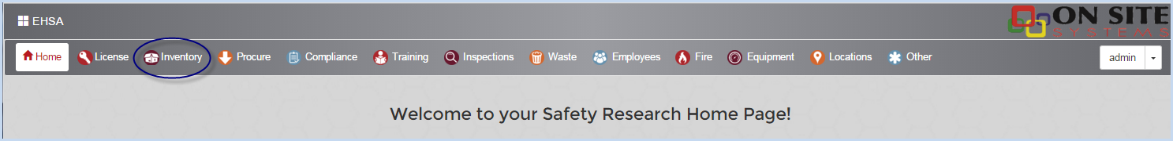

- PI users will select Inventory from the icons shown on the Home Page.
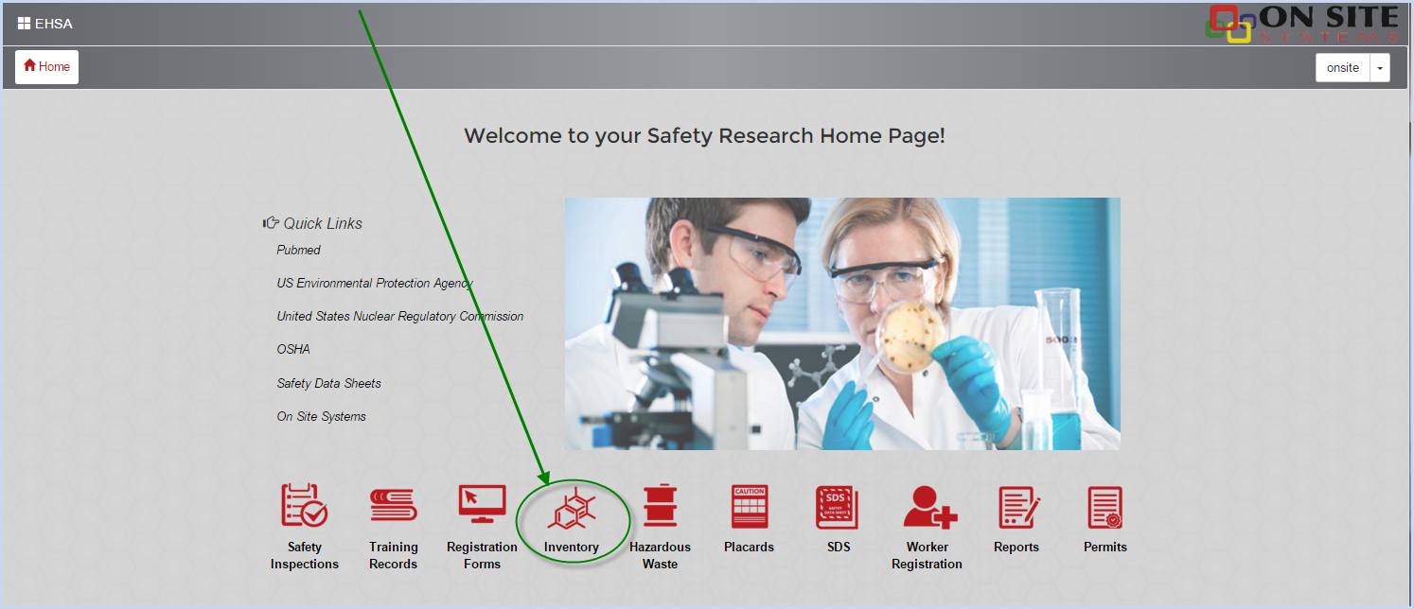

- Select Quick Chemical Entry from under [Chemical Inventory].
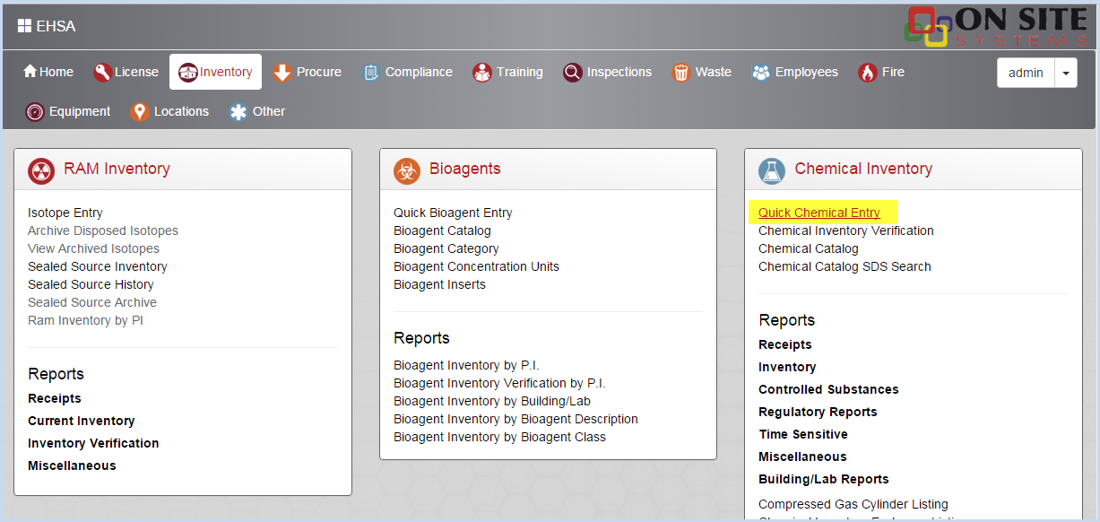

- The Chemical Inventory screen shows a list of all Chemical Inventory items. Use sorts (click on header row column), grouping, and filters to sort or view the list by any column (PI, Chemical Description, etc.). The default view is "Show All PIs". Select an individual PI from the dropdown list to view a single PI's inventory. The Inventory dropdown allows the user to view "Current Inventory" or "Disposed Inventory". The default view is Current Inventory.
- Click the "View all Shared Inventory" to show just the shared inventory items. The default view is all items, showing a check in the Shared column if the items is shared.
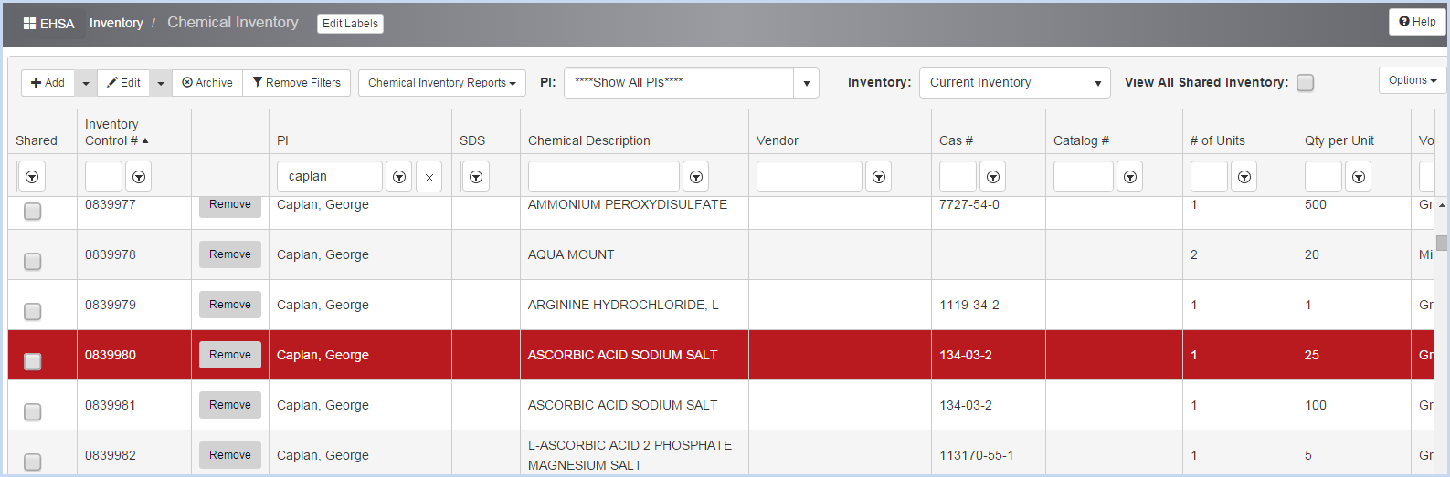

Chemical Inventory Quick Add

The Quick Add feature allows the user to add a chemical inventory item without a Requisition.

- From the Chemical Inventory screen, click the Arrow beside the [+Add] button and then click [Quick Add].
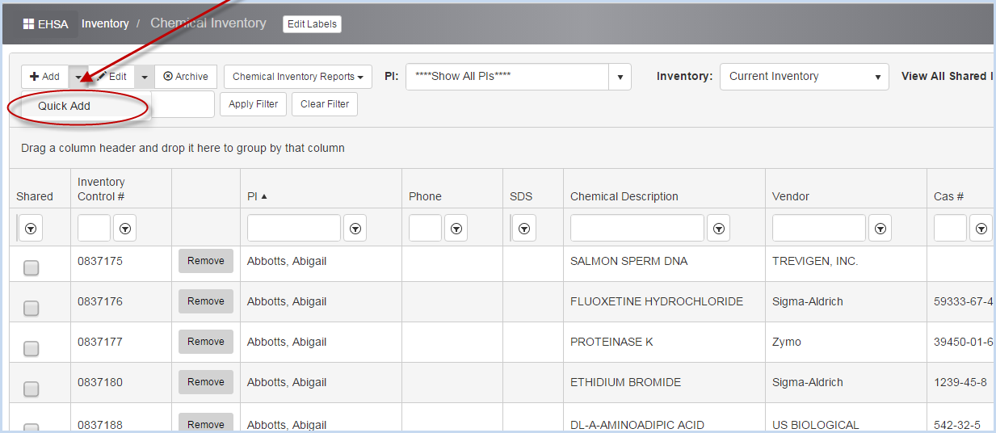

- This opens the Quick Add Chemical Inventory screen.
- Select the Authorized User or P.I. from the dropdown list. PI's and Lab Managers will be limited to the list of PI's they are authorized to access.
- Then select a Permit # for the Authorized User chosen.
- Required fields are noted or marked with an *.
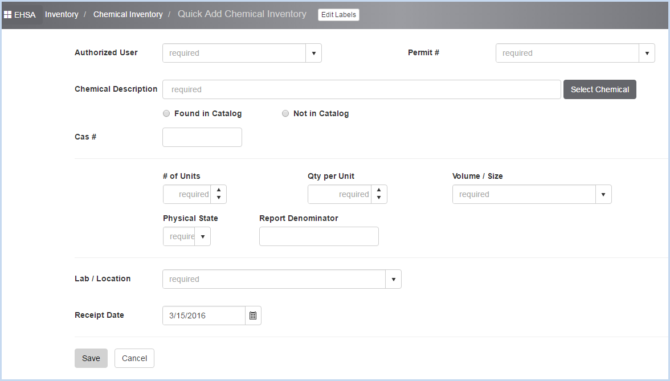

- On the Chemical Inventory screen if an individual PI's inventory was selected for viewing as shown below and the user clicks [Quick Add],
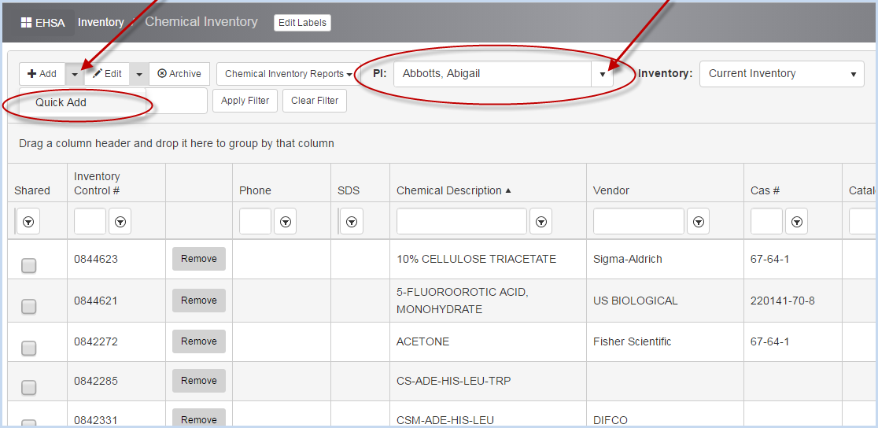

then the Quick Add Chemical Inventory screen will open with the Authorized User filled in as shown below.
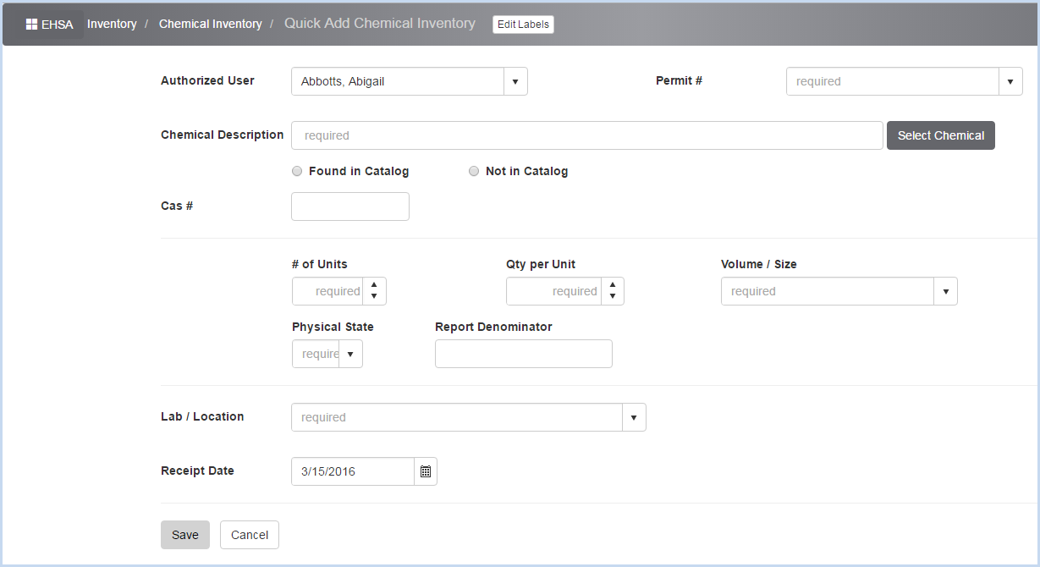

- Select the Permit # to attach the chemical to from the list of the selected PI's permits. This is a required field.
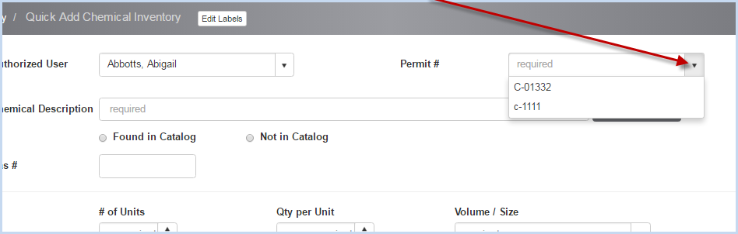

- Continue entering data in the Chemical Inventory fields.
- Click [Select Chemical] to open the [Select Chemical] search box.
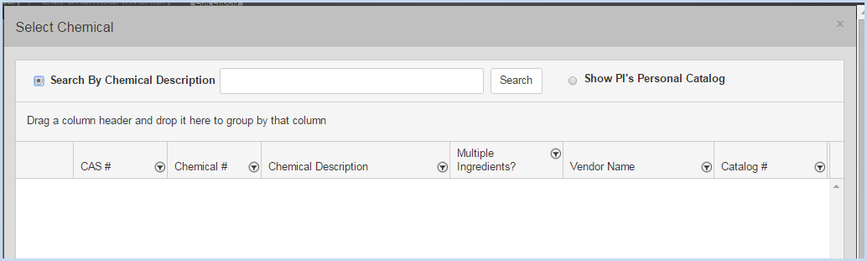

- Select Search by Chemical Description and enter a Description, or Show PI's Personal Catalog.
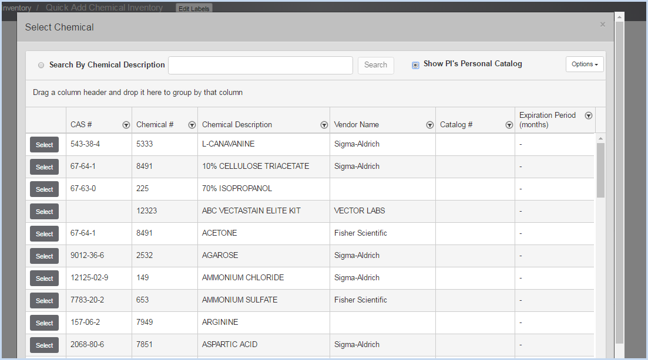

- Click [Select] for the chemical you wish to add. This will populate the chemical information - Chemical Description and CAS# (if available) will fill in.
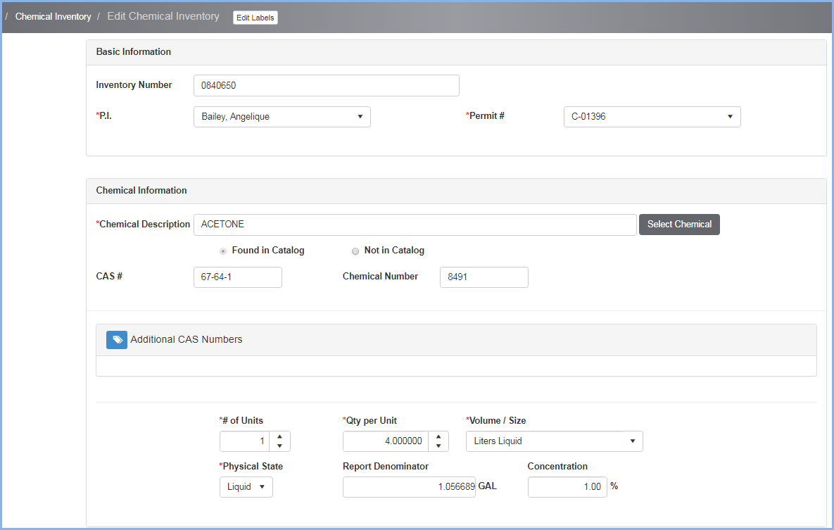

﻿
- Enter the # of Units, Qty per Unit, Volume/Size, and Physical State.
- The Report Denominator will calculate based on the Unit, Volume, and Size entry details.
- Enter the Concentration.
- The Receipt Date will default to the current date. Edit if necessary.
- Select Yes/No if Chemical Will Expire.
- Enter the Expiration Date if the Chemical will expire.

Scroll down to view Vendor, Location and Dates section:
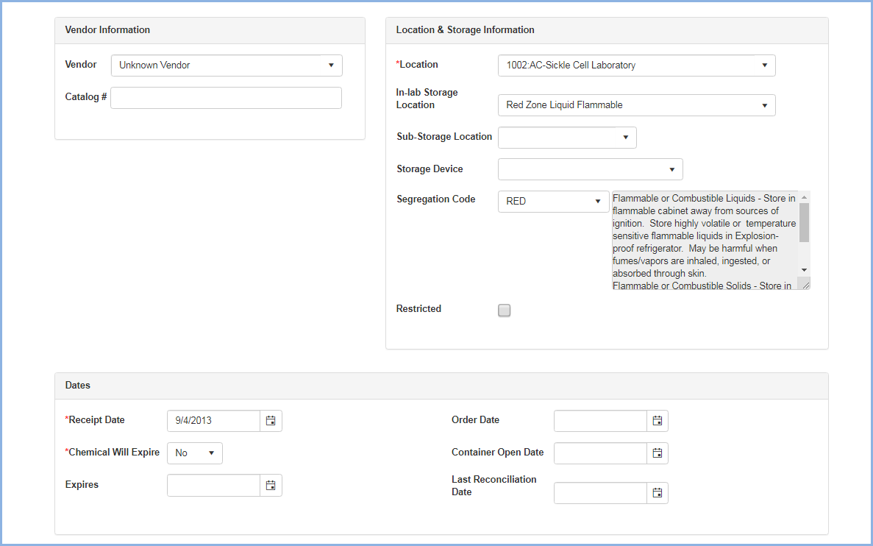
- Select the Vendor and Catalog # (for Vendor) if applicable.
- Select the Lab/Location from the dropdown of labs for the PI on the Permit that was selected.
- Select/enter In-Lab Storage Location as applicable/needed.
- Select/enter Sub-Storage Location as applicable/needed.
- Select/enter Storage Device as applicable/needed.
- Select the Segregation Code as applicable.
- Check if the chemical item is Restricted. If Restricted is checked, this indicates it is a highly hazardous chemical and viewing this inventory item will be limited to users in a security group with authorization to view Restricted items.
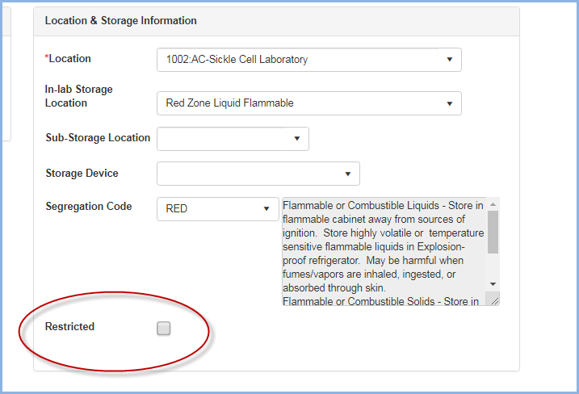

- Enter the Order Date as needed.
- Enter the Container Open Date as needed.
- The Last Reconciliation Date will auto-fill the last date the inventory item was verified.

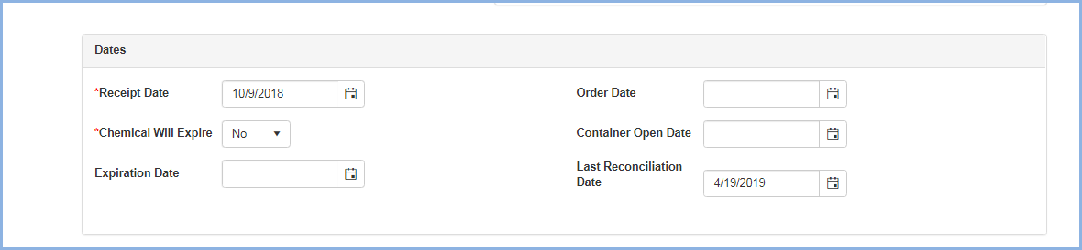

Scroll down to view The Hazard Information and SDS Information & Documents sections:
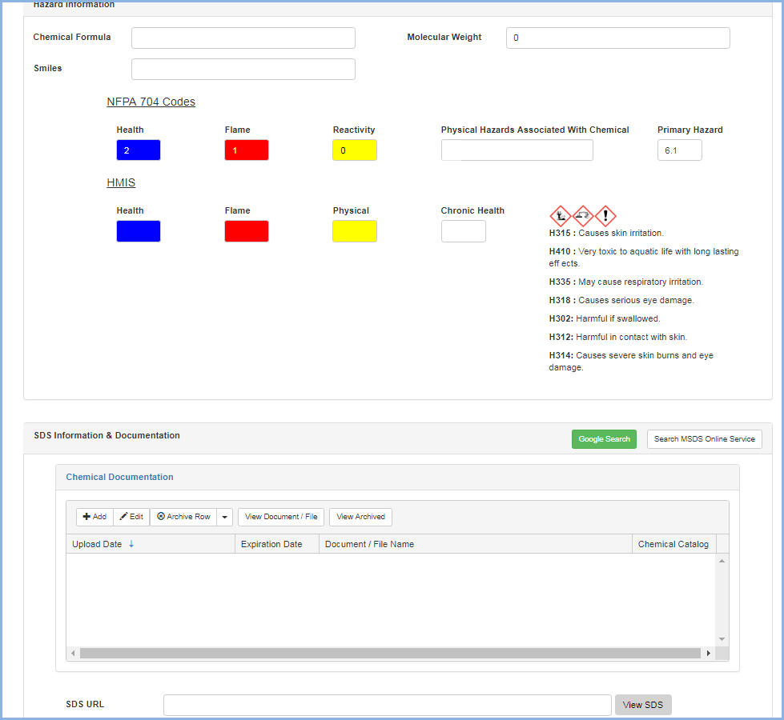

Scroll down to view the Contact Information, Comments, and Record Addition Information
- Select the Contact from the dropdown - these will be the contacts from the Permit selected for this entry.
- The Contact's Phone and Email will auto-fill.
- Enter any Comments as needed.

- The Record Addition Information will auto-fill with the information of the user entering the inventory item.
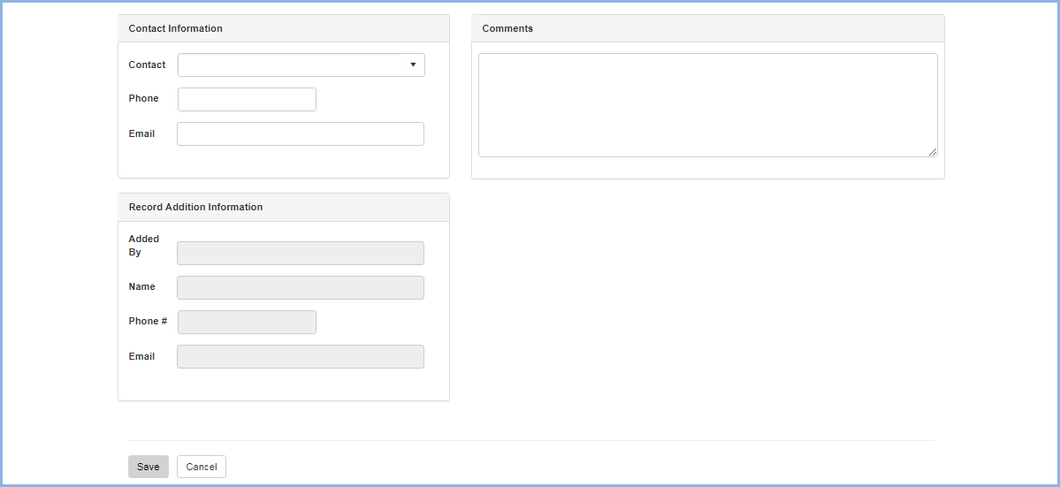

- Click [Save] to save the record, or click [Cancel] to discard the entry.

