Slythering Hufflegryphs

Slythering Hufflegryphs
Usability Test Findings and Analysis Report
Usability, Testing, and Design - RHET 4372
May 1st

Table of Contents
Table of Contents
Executive Summary
Introduction and Project Background
Project Goals
Report Structure
Methodology
Think-aloud Protocol
Number of Participants
Testing Overview
Usability Testing participants
Recruiting Process
Participant Overview
Description of Scenarios - Undergrad Students
Description of Scenarios - Graduate Student
Description of Scenarios - Faculty
Findings
Undergrad Findings
Grad Findings
Faculty Findings
Pre-Test Questionnaire Analysis
Post-Test Questionnaire Analysis
Product Reaction Cards Analysis
Undergrad Product Reaction Cards Analysis
Grad Product Reaction Cards Analysis
Faculty Product Reaction Cards Analysis
Recommendations and Conclusion
References
Appendix
Appendix A - Scenarios and Tasks
Undergrad Scenarios and Tasks
Grad Scenarios and Tasks
Faculty Scenarios and Tasks
Appendix B - Pre-Test Questionnaire
Appendix C - Post-Test Questionnaire
Appendix D - Product Reaction Cards

Executive Summary
The purpose of this usability test is to evaluate the usability of the Ottenheimer Library website (ualr.edu/library). Our study focuses on the following:
- Error Tolerance and Recovery
- Efficiency
- Initial reactions and post reactions to the website
- Document user questions on presentation, resources, and accessibility
- Test reaction to content and inconsistencies
The usability test will include separate scenarios and tasks for undergraduate, graduate, and faculty. The undergraduate group will have six scenarios completed by four participants. The graduate group will have six scenarios completed by three participants. The faculty group will have four scenarios completed by three participants. The tests will be conducted in the Student Union A building, room 106C at the University of Arkansas at Little Rock. The test will include a pre-test questionnaire, post-test questionnaire, and product reaction cards.
The usability test plan includes:
- Problem Statement and Test Objectives
- User Profile
- Test Methodology
- Scenarios
- Evaluation Methods
- Test Environment and Equipment
- Project Timeline
- Deliverables
- Test Artifacts
  - Moderator Script
  - Personas
  - Video Consent Form
  - Pre-Test Questionnaire
  - Post-Test Questionnaire
  - Product Reaction cards (words)
The deliverables for this usability test include:
- Meeting with client to go over results
- Informal report of findings with class
- Formal report of findings with library staff

The team recruited ten participants and the usability testing occurred between March 15th to April 10th. There were four participants for undergraduate testing, three for graduate testing, and three for faculty testing. The following list items are a few, brief, results found from the usability testing. Please review the Findings section for the full report.
- All of the participants had positive reactions to the website as a whole.
- All Graduate participants had difficulty finding video tutorials.
- Six out of ten participants made negative comments about the side navigation on the home page.
- Three out of three graduate students made negative comments about the video tutorials’ location.
Based on our results gathered from the project, the Slythering Hufflegryph team makes the following recommendations to improve the usability of the website:
- Edit the side navigation for consistency and order; make sure linking content is relevant to child pages.
- Consider changing the “Quick Search” tab results for Databases.
- Consider repositioning pages closer to the home page if important.
  - How-to-Videos
- Remove excess library hours and keep the hours page from the side navigation (http://ualr.edu/library/about/library-hours/)
- For pages that are “heavy” in content and resources, consider adding a top bar navigation.
- Consider making “One-on-One Research Consultation” higher in page real estate (http://ualr.libanswers.com/ask)
- Reduce amount of side advertisements on homepage.

Introduction and Project Background
The Slythering Hufflegryphs usability team is made up of five students (one graduate and four undergraduate) in the Usability Testing & Design (RHET 4372/5372) at the University of Arkansas at Little Rock (UA Little Rock). The five group members are the following:
- Tanner Sullivan - test logger
- Melissa Johnson - graduate student leader and test logger
- Kristena Merritt - test moderator
- Erica Avelar - test moderator
- Preston Kearns - test observer
The usability team administered the usability testing on the Ottenheimer Library website between March 15th and April 10th. The Usability Testing & Design (RHET 4372/5372) professor, Joseph Williams, professor in the Rhetoric and Writing Department, provided guidance for test development and implementation. The project was completed in three phases:
- Creating personas and scenarios of targeted users that might use the Ottenheimer Library Website.
- Gathering and conducting usability testing with participants.
- Analyzing the results and giving recommendations based on the findings from the usability testing

Project Goals
Slythering Hufflegryphs’ goal is to empower users for making a difference in web design. The goal of this project is to uncover users’ impressions of the Ottenheimer Library Website.
After talking with our client, Cori Schmidtbauer, eLearning Librarian for the Ottenheimer Library, we aimed to explore the following about the Ottenheimer Library Website:
- How do users navigate through the website?
- Do users find the side navigation menus intuitive?
- Which methods for finding the same information are most effective and efficient?
- Do users notice errors and inconsistencies in the website and how do they react?
- Are users able to find information they are looking for in a timely manner?
- Are users able to access resources they are looking for in a timely, intuitive, manner?
- If users make a mistake, are they able to recover from the mistake and proceed through the website?

Report Structure
This report includes the following sections:
- Methodology - includes an outline of the test process and equipment, scenarios and tasks used in the usability testing, and information on the usability testing participants.
- Findings - details results from the usability test, organized by user group, by scenario.
- Post-Test Questionnaire Analysis - contains results of the post-test questionnaire the usability testing participants received at the end of the testing session.
- Product Reaction Cards Analysis - describes results from the product reaction card activity the usability testing participants performed at the the end of the session.
- Recommendations and Conclusion - gives recommendations to the client from user results and a summary of explanations.
There are appendices which contain documents from our usability testing.
The following documents are included in the appendices:
- Appendix A: Personas - two user profiles of targeted participants
- Appendix B: Moderator Script - read to each participant for every usability session.
- Appendix C: Scenarios and Tasks - read to respective participant group during usability session.
- Appendix D: Video Consent Form - copy of the release form given to each participant. Includes signed forms from participants.
- Appendix E: Pre-Test Questionnaire - given to each participant before testing began.
- Appendix F: Post-Test Questionnaire - given to each participant once testing concluded.
- Appendix G: Product Reaction Cards - list of product reaction card words given to each participant after the post-test questionnaire was complete.
- Appendix H: Usability Testing Plan - copy of the usability test plan used to plan the usability testing sessions through the project.

Methodology
The test plan is designed to examine the Ottenheimer Library website (ualr.edu/library) using the Quesenbery 5Es.
- Effective
  - Can users effectively complete goals?
- Efficient
  - Can users complete goals quickly?
- Engaging
  - Do users enjoy using the website?
- Error Tolerant
  - Can the user perform tasks correctly or find resources for help if they need it?
- Easy to Learn
  - Can users use the website correctly the first time they use the website and continue easy learning through future use.

Think-aloud Protocol
One method used for gathering data is through the use of a think-aloud process. During this process the user is encouraged to voice their thoughts and reactions aloud. The think-aloud process gives us insight into the user experience through a first-hand account. This will be recorded and evaluated for the test results.

Number of Participants
We plan to test the website using ten participants. We will attempt to collect four undergraduate students, three graduate students, and three faculty members. There may be issues finding participants that fit our intended categories; we will try our best to recruit users that fit our personas as closely as possible.

Testing Overview
The Slythering Hufflegryph usability team administered formal testing with ten participants in the Old Student Union A building, room 106 C (SUA 106 C) at the University of Arkansas at Little Rock. All of the testing sessions lasted between 15 and 40 minutes. This time included:
- Pre-test Questionnaire completion (via Morae)
- Moderator led testing
- Scenarios and tasks broken down for the following participant groups
  - Undergraduate group - six scenarios and eight tasks
  - Graduate group - six scenarios and six tasks
  - Faculty group - four scenarios and four tasks
The participant will sit at a desk in a classroom equipped with the following:
- 19’ standard monitor on an adjustable mount
- One mounted camera attached to the monitor
  - Camera is equipped with a microphone
- Morae usability software (recorder)
The loggers will operate a computer or laptop with Morae Observer software installed.

Usability Testing participants
This section details the way participants were recruited and an overview of the recruited users.

Recruiting Process
According to the research done and use to create our three personas, the idea users for the Ottenheimer Library website is as follows:
- Attend UA Little Rock
  - Undergraduate Student
  - Graduate Student
  - Faculty member
- Gender - any
- Daily computer activity which includes internet browsing, email, research, etc.
- Live in Little Rock and surrounding areas.
- Performs research using scholastic resources.
The group was able to recruit users that fit most of these guidelines; however, the group was not able to recruit a user that fit all of these guidelines.

Participant Overview
This is a usability test designed for students and faculty of UALR. The Eligibility Criteria is you must be an undergraduate, graduate student, or a faculty member. With that in mind, we were able to recruit 10 users. Out of our ten users, 6 were female and 4 were male. Within each subgroup there were 4 undergraduates, 3 grads, and 3 faculty participants. The undergraduate subgroup had more users because they comprise the majority of demographics for this community.

Participant | Age Range | Gender | Group
P1 | 20-25 | Male | Undergraduate
P2 | 18-22 | Female | Undergraduate
P3 | 40-50 | Female | Undergraduate
P4 | 20-25 | Male | Undergraduate
P5 | 20-25 | Female | Graduate
P6 | 20-25 | Male | Graduate
P7 | 20-25 | Female | Graduate
P8 | 45-55 | Male | Faculty
P9 | 35-45 | Female | Faculty
P10 | 45-55 | Female | Faculty

Description of Scenarios - Undergrad Students
In this section, we provided testers with specific scenarios a “typical” undergraduate student would encounter. They were given as much time as they needed to complete each task. These scenarios were designed to give users an authentic instance in which the UALR Library website is needed.

Scenario 1
Question  How do users feel about going through the website and finding resources? Do users feel that they can find what they need?  (Easy to Learn) | Task  Getting a user understanding of the site’s resources.  Getting a user understanding of the site’s navigation. | Scenario  You are just starting your semester and you have not bought your textbook yet. You need material from the textbook for a class activity in your next Composition 1 class. Your professor, Dr. Brian Ray, mentioned that there are class resources on reserve with the library available for students.
Scenario 2
Question  How will users find information they are looking for within the website. What method of obtaining information is more effective to the user?  Is the side navigation intuitive? Can users find information they are looking for within the menu or do they look elsewhere?  (Efficiency)  (Error Tolerant) | Task  Getting a user understanding of the site’s resources.  There are different ways to get this information.  Users can navigate to the quick search for the topic on the library home page. Users can also go through, search for the database, then search for the article. User can also click on “Articles and Databases” link on side navigation to find the article. It is confusing to which method is most effective and which methods are less effective. | Scenario  You are starting research on a paper in class. You need to access academic journals to support your topic.
Scenario 3
Question  How will users navigate the pages of the website to find the specific resource they’re looking for?  (Efficiency)  (Easy to Learn) | Task  Getting a user understanding of how resourceful the site is. | Scenario  Your instructor advised you to go through the Business Source Complete database to find information for a class project.
Scenario 4
Question  Will users find the resource they need on the website to learn a skill?  (Easy to Learn)  (Effective) | Task  Getting a user understanding of how available services like this are known on the website. | Scenario  You need to write citations for your research project. Your professor requested that you cite in MLA (Modern Language Association) format. The library offers research guides on various topics.
Scenario 5
Question  How will users find the most basic information about the “establishment” on the website?  (Easy to Learn)  (Efficiency) | Task  Getting a user understanding of the site’s resources.  Getting a user understanding of the site’s navigation.  Users can access this resource in different areas. Users can go through the side navigation and access library services. Users can also go to the “Contact Librarian” icon to web-chat with a librarian to schedule a time. It is unclear which method is most efficient for the library website. | Scenario  You see that you’re going to have a lot of assignments due soon and need to start working on them as soon as possible. You need to find out the Library’s contact information and hours so you can plan ahead.
Scenario 6
Question  How will users navigate the website to locate and utilize all of the library’s available resources for research?  (Error Tolerant)  (Easy to Learn)  (Efficiency) | Task  Gain a user perspective of how to search through library resources and find related materials.  There are different ways to get this information. Users can go through | Scenario  Your instructor has assigned you a research paper on the Civil War and has requested that you use a variety of sources (print books, ebooks, videos, etc.).

Description of Scenarios - Graduate Student
We found that the majority of grad students use the library’s website for accessing materials for research. Our scenarios reflect the types of situations grad students would commonly encounter. There were six total scenarios for grad users they include: accessing databases, requesting materials outside the library, finding specific articles, and using resources in the research guides.

Scenario 1
Question  How does the navigation menu provide clues for locating resources?  (Easy to learn)  (Efficiency) | Task  How do users find library resources using the “research guides” tab on the navigation menu? | Scenario  You were informed that the Library has video tutorials on their website. Fellow students said they were very resourceful.
Scenario 2
Question  How do users find how to schedule research consultations with librarians?  (Efficiency)  (Effective) | Task  Getting a user understanding of the site’s resources.  Users can access this resource in different areas. Users can go through the side navigation and access library services. Users can also go to the “Contact Librarian” icon to schedule time or web-chat with a librarian to schedule a time. It is unclear which method is most efficient for the library website. | Scenario  You are working on a large research project and need assistance from a librarian.
Scenario 3
Question  How do users access specific research materials provided by the library?  (Efficient)  (Error Tolerant) | Task  Get an understanding of the ways users access information through a database or through the “quick search” bar. | Scenario  You are constructing an annotated bibliography on an article about American Gangsters of the 1920s and 1930s. You need to find this article for your research.
Scenario 4
Question  How do users locate resources for citation information?  (Effective)  (Efficient) | Task  Discover how users find citation help.  Users can find citation information under the “research guides” tab on the navigational menu. | Scenario  You need to write citations for your research project. Your professor requested that you cite in APA (American Psychological Association) format. The library offers research guides on various topics.
Scenario 5
Question  How do users find how to schedule research consultations with librarians?  (Easy to Learn)  (Effective) | Task  Getting a user understanding of the site’s resources.  Users can access this resource in different areas. Users can go through the side navigation and access library services. Users can also go to the “Contact Librarian” icon to schedule time or web-chat with a librarian to schedule a time. It is unclear which method is most efficient for the library website. | Scenario  You are working on a thesis project and need to request material outside of the Ottenheimer Library.
Scenario 6
Question  How do users find specific databases?  (Error Tolerant)  (Efficient) | Task  Getting a user understanding of what they believe is an efficient way to obtain information.  There are different ways to find this information. You can go to the side navigation and click “Articles and Databases,” or search through quick search and select a database name you feel closely relates to your topic in the query. | Scenario  You need to find a database about Chemistry. You do not know the name of the database.

Description of Scenarios - Faculty
We provided testers with specific scenarios a “typical” faculty member might encounter. They were given as much time as they needed to complete each task. These scenarios were designed to give users an authentic instance in which the UALR Library website is needed.
Scenario 1
Question  How do users access different areas of the library website?  (easy to learn)  (efficiency) | Task  Discover how people navigate the library website to find this information. | Scenario  In two weeks, you want to take your class to the library and give them an instructional session to get them familiar with the library and how to utilize its resources.
Scenario 2
Question  How intuitive is the library website to navigate?  (effectiveness)  (easy to learn) | Task  Get an understanding of the ways in which users interpret words and phrasing on the website. | Scenario  You were hoping to find a book you found to be valuable in your research in the library, but unfortunately, in all of your searching, it appears the library does not have the book.
Scenario 3
Question  What do users look for when they need to reserve textbooks on the library website?  (easy to learn)  (effectiveness)  (efficiency) | Task  Figure out where users look and what they look for. | Scenario  You want to put the textbook you are using for your class on reserve at the library for your students to use.
Scenario 4
Question  What methods do users perform to find their account information?  (effectiveness)  (efficiency)  (easy to learn) | Task  Learn the routes most used to get into a user’s library account | Scenario  You have several books checked out from the library. You want to know what books you have as well as when they are due.

Findings
The team used Morae Manager software to compile our data into quantitative charts of the findings for each category (Undergraduate, Graduate, Faculty).

Undergrad Findings
The charts below display the success distribution by task and the average time spent on each task. According to the data, 4 out of 8 tasks had a 100% success rate that were completed with ease while 3 out of 8 tasks were not completed (users failed). From this data, it is apparent our tasks were, mostly, able to be completed by an Undergrad user. As stated in previous sections, these tasks were designed to mirror tasks Undergrad students would actually need to perform using the Library website.
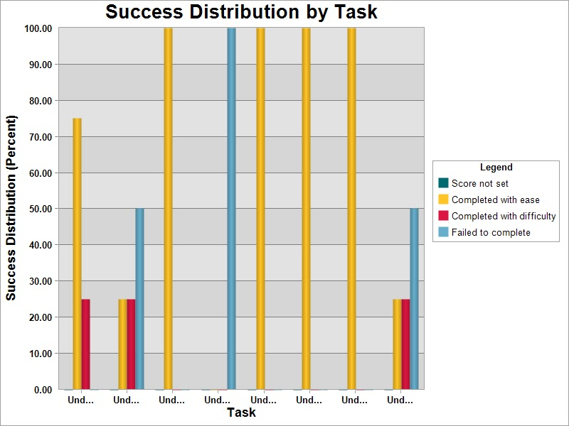
This next chart displays the average time spent on tasks by task. The longest time an Undergrad user spent on a task was about 3 minutes while the shortest time was less than 1 minute. The 3 tasks that had a 100% completion rate with ease were also the tasks users completed in less than 50 seconds. This data gives us a general idea of how long “simple “ student tasks using the UALR Library website may take in it’s current state.
Undergrad users were consistent in their audible statements of either confusion or confidence. These statements occurred within seconds of beginning a task. When confused, the Undergrad users responded with statements such as, “I think this is it, but I’m not sure”, or “I’m not sure, but I think that would work.” It was a trend that the longer it took for users to complete a task, the more they would share their confusion.
- The specific tasks and scenarios may be found in Appendix C.
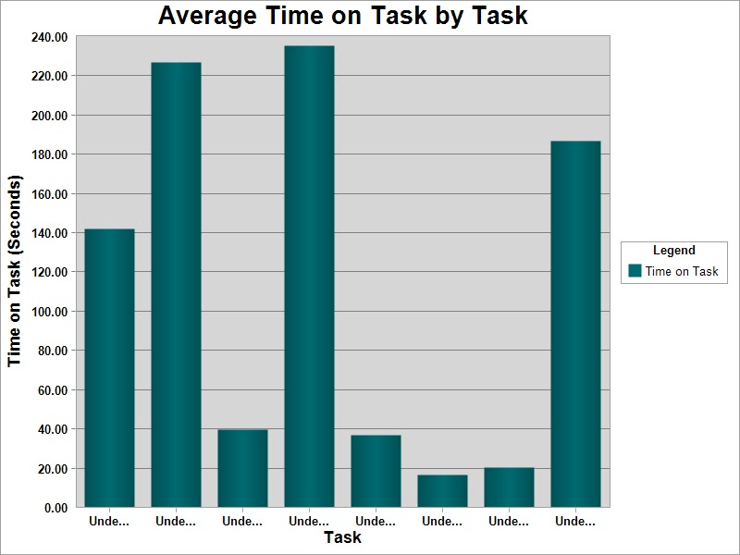

Grad Findings
For our graduate users we were concerned with how users access resources and information from databases and library’s research guides.
The chart below displays the user success rate by task. The x-axis displays the tasks in chronological order from left to right.
For task 1, 2 out of 3 grad users failed to locate the video tutorials. The one user who completed the task did so with difficulty using the UALR search bar, not the library’s “research guides” tab.
Task 2, all users completed the task to schedule an appointment with a librarian with some difficulty.
Task 3, finding a specific article, was the only task with a 100% completion rate. Each user intuitively uses the “quick search” bar to look up the article and find the full text. In task 4, all three users completed the task, but one user had a lot of difficulty finding APA citation help. Task 5 was to request material outside of the UALR library. All users completed this task, but one user experienced some difficulty.
Task 6, had a range of results depending on where the user expected to find a chemistry database. One user chose to use the “database” tab located in the center of the page versus using “articles & databases” in the side menu under “find.” He then selected “academic search complete” to search for chemistry in the search bar which brought up articles and videos for chemistry, not a chemistry database. This user failed to complete the task because of this.
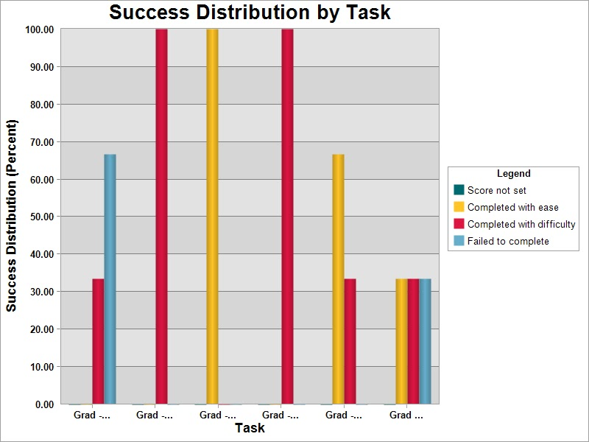

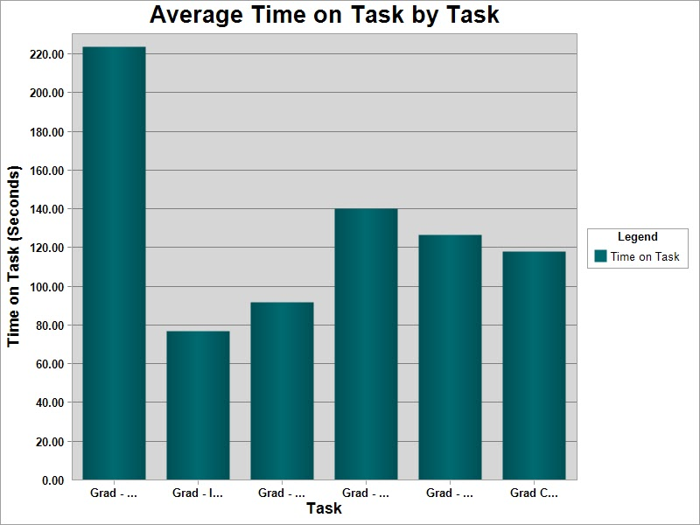
The specific tasks and scenarios may be found in Appendix C.

Faculty Findings
For our faculty users, we were concerned with how users perform their faculty-specific tasks. The charts below displays the user success rate by task and the average time it took users to either complete the task or declare they were giving up. The x-axis display the tasks in chronological order from left to right.
It is also important to note that three users participated in the faculty section of our testing, but one of the videos, User P9, was corrupted. We only have the data collected from the live test and cannot access the video for further information.
Task 1, request a library instruction session, was not completed successfully by any of our users. On average, it took approximately 4.08 minutes for users to declare they were giving up. P8 did not explore much of the site before giving up, and spent most of the time reading the information on the “About the Library” page, “Distance Learning Services,” and “Request Assistance” inside the DLS page. P10 kept going to “Course Reserves,” and she used the search bars—both Quick Search and the UALR website search—anytime she got stuck on a task. Eventually, she went to the “Need Help?” chat feature and asked “How can I reserve a room at the library?” She was told she would have to call the Administration Office. She then asked, “Is there are way to reserve a room on the website?”
Task 2, suggest a book to purchase, was completed by 2 out of 3 of the users. On average, it took the users 2.01 minutes to either complete the task or declare they were giving up. P8, the user that did not succeed, stated, “Because I’m not really finding how I would order a particular book...I would probably just chat with them.”
Task 3, reserve a textbook for your course, was failed by all three of the users. On average, it took users 1.25 minutes before declaring that they were giving up. 2 of the 3 users did not understand the name “Course Reserves,” assuming it must be referring to something else. P9 found the “Course Reserves” page and attempted to reserve a book, but had difficulty finding the area where she could reserve one for her own class.
Task 4, find out how many books you have checked out, was completed by all the users with very little difficulty.
Figure: Success Distribution by Task (Faculty)
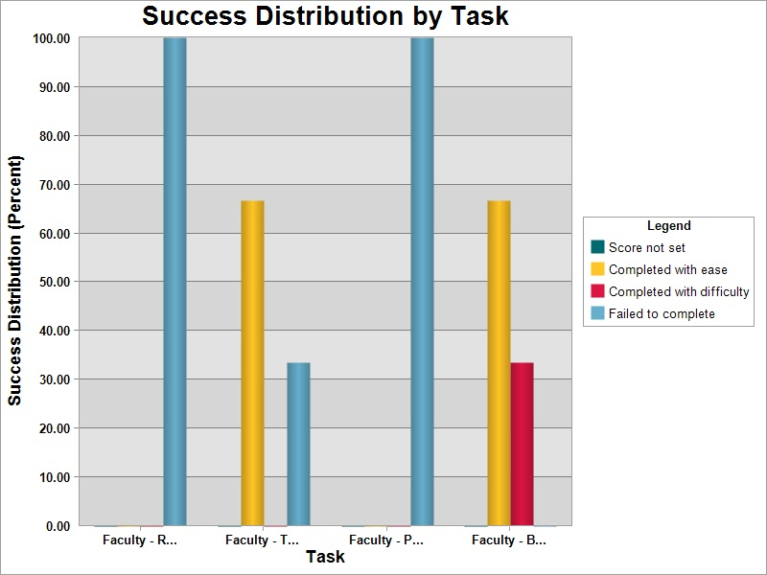
Figure: Average Time on Task by Task (Faculty)
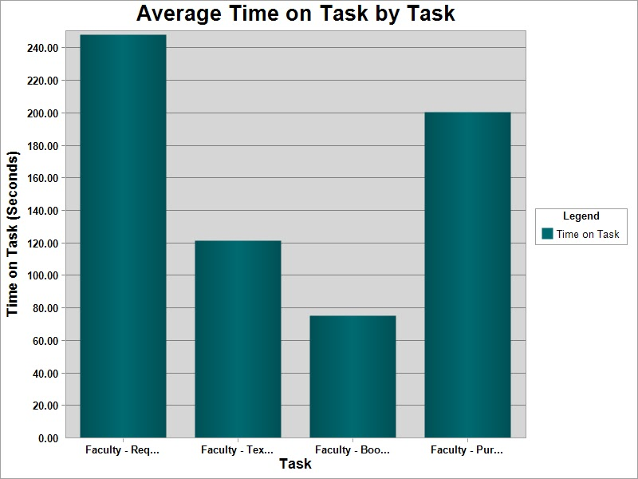

Let’s not worry about it. Delete me when ya done <3

Post-Test Questionnaire Analysis
After testing concluded, participants were asked to answer four questions. This included rating how difficult or easy it was to navigate the UALR Ottenheimer Library website and to search for specific journal titles on a scale from 1(very easy) to 10 (very difficult).
The chart below shows the general impression of users by color codes in accordance with their answers to the questions found in Appendix F. Overall, the website falls in the “moderately difficult” range of usability. Users were quick to quantify their experience by selecting a number in the middle range while their qualitative experience (in the following sections) reflected more decisive impressions. 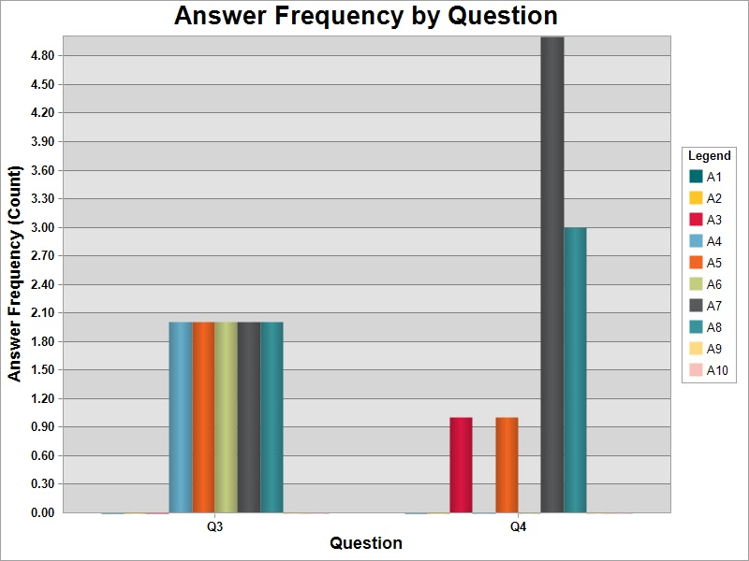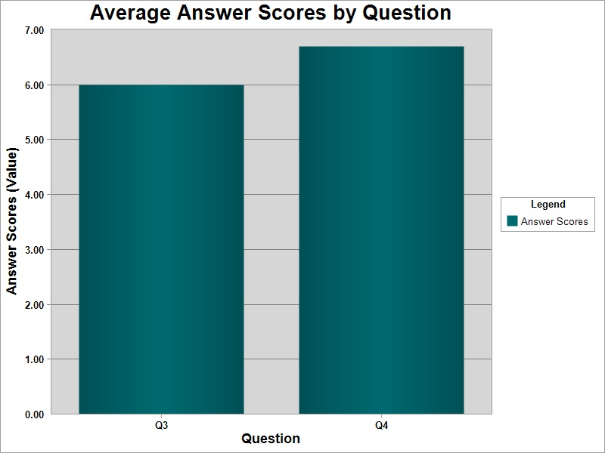
The chart above depicts data of the average answer scores by question. Questions 3 and 4 used difficulty ratings (from 1 to 10) to be chosen by each user . According to the data, the majority of users found the UALR Library website moderately difficult to use with the highest rating (closer to ‘Very difficult’) at 7 and the lowest rating (closer to ‘Very easy’) at 6.
With this data, we wanted to find the general impression of users on the ease of usability of the website. Using quantitative data for this section of the questionnaire is essential since qualitative analysis requires a different set of heuristics. We were able to produce an overview of user’s opinion of the ease of use by this chart of the majority ratings.

Product Reaction Cards Analysis
We asked each of our users to select as many or as few of 20 reaction cards that they felt represented the library website. Fourteen cards were positive and five were negative. The following table contains the reaction cards each user chose.

Table: Reaction Cards Chosen by Users
Word | Undergraduate | Graduate | Faculty | Total
Accessible | 2 | 2 | 1 | 5
Approachable | 1 | 2 | 2 | 5
Consistent | 2 | 1 | 0 | 3
Convenient | 3 | 2 | 2 | 7
Efficient | 2 | 1 | 0 | 3
Effortless | 0 | 1 | 0 | 1
Engaging | 1 | 2 | 0 | 3
Essential | 3 | 1 | 1 | 5
Helpful | 3 | 2 | 2 | 7
Intuitive | 1 | 1 | 0 | 2
Organized | 1 | 2 | 0 | 3
Timesaving | 2 | 2 | 2 | 6
Useful | 4 | 3 | 2 | 9
Valuable | 4 | 1 | 2 | 7
Confusing | 2 | 3 | 1 | 6
Hard to Use | 1 | 2 | 1 | 4
Ineffective | 0 | 1 | 0 | 1
Overwhelming | 1 | 2 | 1 | 4
Undesirable | 0 | 1 | 0 | 1

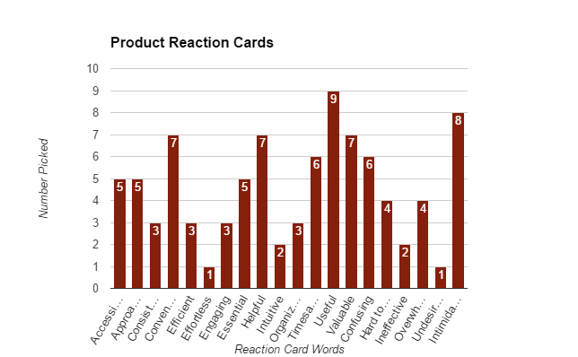
The cards chosen most to describe the Ottenheimer Library website were “useful,” “convenient,” “helpful,” “valuable,” “timesaving,” and “confusing.”
The cards chosen least of the words available were “effortless,” ineffective,” “undesirable,” “intuitive,” “consistent,” “engaging,” and “organized.”

Based on the selections made by our 10 users, it seems their overall feelings of the website are that they recognize it as a valuable asset to their learning experience at the University of Arkansas at Little Rock, but they also see that it have several weaknesses, such as being unorganized, confusing, and unintuitive.

Undergrad Product Reaction Cards Analysis
The undergraduates in our test unanimously agreed that the website was “useful” and “valuable.” The undergraduates also chose a disproportionate number of positive words, most of which involved the value of the library’s website, indicating that even as undergraduates, they all appreciate the resource. “Effortless” was not chosen by any of the undergraduate users, indicating that they had to work in order to complete their assigned tasks.

Grad Product Reaction Cards Analysis
The graduates in our test unanimously agreed that the website was “useful” but “confusing.” The number of negative words chosen is about even to the number of positive words, proportionally, indicating a difference from the undergraduates, who had more positive things to say than negative. This could happen for a number of reasons: a.) the tasks given to the graduate students were more challenging than the ones given to the undergraduates, b.) the undergraduates want to protect the feelings of the creators of the library website while the graduate students want to give a more accurate representation of their feelings, or c.) perhaps the graduate students have been exposed to the website longer and are somewhat jaded, as compared to the undergraduates, who are still naïve.
Some of the cards that were chosen least by the graduate users were “valuable” and “intuitive.” This indicates a lack of ease and perhaps importance in the webiste.

Faculty Product Reaction Cards Analysis
The faculty in our test did not unanimously agree on any words. There was a greater number of positive words than negative, proportionately, and the words chosen most were “valuable,” “useful,” “timesaving,” “helpful,” and “approachable.” Words that received no votes by the faculty users were “organized,” “intuitive,” “effective,” and “efficient.”
Again, this implies that the users recognize the importance of the library’s website, but also feel that there is plenty of room for improvement.

Recommendations and Conclusion
With the analysis of both qualitative and quantitative data, the Slythering Hufflegryph team makes the following recommendations to improve the usability of the website:
To improve Error Tolerance & Recovery:
- Edit the side navigation for consistency and order; make sure linking content is relevant to child pages.
- Consider changing the “Quick Search” tab results for Databases.
- Consider repositioning pages closer to the home page if important.
  - How-to-Videos
- Consider Adding categories (additional pages) for faculty separate from student interactions
To improve Efficiency:
- Remove excess library hours and keep the hours page from the side navigation (http://ualr.edu/library/about/library-hours/)
- For pages that are “heavy” in content and resources, consider adding a top bar navigation.
- Consider making “One-on-One Research Consultation” higher in page real estate (http://ualr.libanswers.com/ask)
- Reduce amount of side advertisements on homepage.

References
Benedek, J. & Miner, T. (2002). Product Reaction Cards. Microsoft Corp. Retrieved from http://www.google.com/url?sa=t&rct=j&q=&esrc=s&source=web&cd=1&ved=0CDIQFjAA&url=http%3A%2F%2Fwww.microsoft.com%2Fusability%2Fuepostings%2FProductReactionCards.doc&ei=9SQyUaHF4i69gTytYGgDg&usg=AFQjCNEBGMU6yXU_X4dIA9QS0XN8NpfhZQ&bvm=bv.43148975,d.eWU

Quesenbery, W. (2011).Using the 5Es to understand users. Retrieved from http://wqusability.com/articles/getting-started.html

Usability.gov (n.d.). Templates. Retrieved from http://usability.gov/templates/index.html

Appendix A - Scenarios and Tasks

Undergrad Scenarios and Tasks
Scenario 1:
You are just starting your semester and you have not bought your textbook yet. You need material from the textbook for a class activity in your next Composition 1 class. Your professor, Dr. Brian Ray, mentioned that there are class resources on reserve with the library available for students.
- Task 1
  - Navigate through the Library’s website and see if the material for your Composition 1 class is available or not. Please remember to voice your thoughts aloud. Once you feel you have completed the task, please let me know.
Scenario 2:
You are starting research on a paper in class. You need to access academic journals to support your topic.
- Task 1
  - Search for the Arkansas Historical Quarterly journal on the website. Please remember to voice your thoughts aloud. Once you feel you have completed this task, please let me know.
Scenario 3:
Your instructor advised you to go through the Business Source Complete database to find information for a class project.
- Task 1
  - Navigate through the website and find the Business Source Complete database. Please remember to voice your thoughts aloud. Once you feel you have completed the task, please let me know.
Scenario 4:
You need to write citations for your research project. Your professor requested that you cite in MLA (Modern Language Association) format. The library offers research guides on various topics.
- Task 1
  - Navigate through the Library’s website to learn how to create a citation in MLA format. Please remember to voice your thoughts aloud. Once you feel you have completed the task, please let me know.

Scenario 5:
You see that you’re going to have a lot of assignments due soon and need to start working on them as soon as possible. You need to find out the Library’s contact information and hours so you can plan ahead.
- Task 1
  - Navigate through the Library’s website and find their contact information. Please remember to voice your thoughts aloud. Once you feel you have completed the task, please let me know.
- Task 2
  - Navigate through the Library’s website and find their hours for today. Please remember to voice your thoughts aloud. Once you feel you have completed the task, please let me know.
- Task 3
  - Navigate through the Library’s website and find their hours for April 10th, 2017. Please remember to voice your thoughts aloud. Once you feel you have completed the task, please let me know.

Scenario 6:
Your instructor has assigned you a research paper on the Civil War and has requested that you use a variety of sources (print books, ebooks, videos, etc.).
- Task 1
  - Navigate through the library’s website and find resources for your paper topic. Please remember to voice your thoughts aloud. Once you feel you have completed the task, please let me know.

Grad Scenarios and Tasks
Scenario 1:
You were informed that the Library has video tutorials on their website. Fellow students said they were very resourceful.
- Task 1
  - Navigate through the library’s website and find their video tutorials. Please remember to voice your thoughts aloud. Once you feel you have completed the task, please let me know.
Scenario 2:
You are working on a large research project and need assistance from a librarian.
- Task 1
  - Navigate through the Library’s website and find where you could schedule some instruction consultation with a librarian. Please remember to voice your thoughts aloud. Once you feel you have completed the task, please let me know.
Scenario 3:
You are constructing an annotated bibliography on an article about American Gangsters of the 1920s and 1930s. You need to find this article for your research.
- Task 1
  - Navigate through the Library’s website and find the article titled, “Honorable Style in Dishonorable Times: American Gangsters of the 1920s and 1930s.” Please remember to voice your thoughts aloud. Once you feel you have completed the task, please let me know.
Scenario 4:
You need to write citations for your research project. Your professor requested that you cite in APA (American Psychological Association) format. The library offers research guides on various topics.
- Task 1
  - Navigate through the Library’s website to learn how to create a citation in APA format. Please remember to voice your thoughts aloud. Once you feel you have completed the task, please let me know.
Scenario 5:
You are working on a thesis project and need to request material outside of the Ottenheimer Library.
- Task 1
  - Navigate through the Library’s website and find where you would submit a request for material from another library. Please remember to voice your thoughts aloud. Once you feel you have completed the task, please let me know.

Scenario 6:
You need to find a database about Chemistry. You do not know the name of the database.
- Task 1
  - Navigate through the Library’s website and find a database that focuses on Chemistry. Please remember to voice your thoughts aloud. Once you feel you have completed the task, please let me know.

Faculty Scenarios and Tasks
Scenario 1: In two weeks, you want to take your class to the library and give them an instructional session to get them familiar with the library and how to utilize its resources.

- Task 1: Find the page where you would request a library instruction session for your course. Please remember to voice your thoughts aloud. Once you feel you have completed the task, please let me know.

Scenario 2: You were hoping to find a book you found to be valuable in your research in the library, but unfortunately, in all of your searching, it appears the library does not have the book.

- Task 1: Find the page on the Library’s website where you can submit a request to purchase a book to add to the library’s collection. Please remember to voice your thoughts aloud. Once you feel you have completed the task, please let me know.

Scenario 3: You want to put the textbook you are using for your class on reserve at the library for your students to use.

- Task 1: Find the page on the library’s website where you can put your textbook on reserve. Please remember to voice your thoughts aloud. Once you feel you have completed the task, please let me know.

Scenario 4: You have several books checked out from the library. You want to know what books you have as well as when they are due.

- Task 1: Go to the area of the website where you would find that information. Please remember to voice your thoughts aloud. Once you feel you have completed the task, please let me know.

Appendix B - Pre-Test Questionnaire
- Please select a gender you identify with.
  - Male
  - Female
- Please select your age group.
  - 18–25
  - 26–35
  - 36–45
  - 46–55
  - 56–65
  - 66–75
  - 75+
- Please select your academic status.
  - Undergraduate
  - Graduate
  - Doctoral
  - Faculty
  - Staff
  - Non-degree Seeking Student
- Please select your college.
  - Arts, Letters, and Sciences
  - Business
  - Health Education Profession
  - Engineering Information Technology
  - Law School
  - Social Sciences Communication
  - Grad School
  - Doctoral School
- Have you participated in any online programs (online classes, etc.)
  - Yes
  - No
- Do you live 50 mile or more away from campus?
  - Yes
  - No
  - I don’t know
- What type of classes are you taking/teaching?
  - On-campus only
  - Online only
  - Both on-campus and online
  - None
- Which browser do you prefer?
  - Google Chrome
  - Mozilla Firefox
  - Microsoft Edge
  - Internet Explorer
  - Opera
- What device(s) do you often use to browse the Internet?
  - Desktop
  - Laptop
  - Tablet
  - iPad
  - iPhone
  - Android phone
- Have you been to the Ottenheimer Library before?
  - Yes
  - No
- What services have you used from the Library?
  - [open response]

Appendix C - Post-Test Questionnaire
- Have you accessed the Library’s website from within Blackboard?
  - Yes
  - No
  - I didn’t know this was possible
- Have you used the Library’s online catalog before?
  - Yes
  - No
- I feel like the Library’s website is difficult to navigate.
  - Very difficult 1 2 3 4 5 6 7 8 9 10 Very easy
- How difficult is it to search for a specific journal title?
  - Very difficult 1 2 3 4 5 6 7 8 9 10 Very easy

Appendix D - Product Reaction Cards

Positive
Helpful | Useful | Valuable | Timesaving | Essential
Overwhelming | Convenient | Approachable | Intuitive | Consistent
Effortless | Efficient | Engaging | Organized | Accessible
Negative
Hard to Use | Ineffective | Confusing | Undesirable | Intimidating

