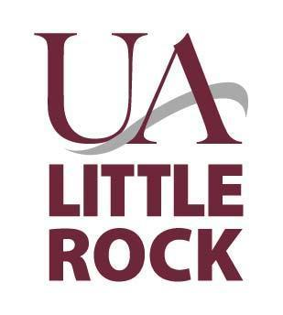
University of Arkansas at Little Rock
2801 South University
Procurement Services Building
Little Rock, Arkansas 72204

Financial Proposal
UA Little Rock FB-23-004

CAUTION TO VENDOR

Vendor’s failure to submit required items and/or information as specified in the Bid Solicitation Document shall result in disqualification.

University of Arkansas at Little Rock
Procurement Services
2801 South University
University Services Building C100
Little Rock, Arkansas 72204

Substance Abuse Prevention – COVID 19 Supplement: Methamphetamine Prevention Grant
Financial Proposal (Separate Sealed Envelope)
All respondents are required to complete the following financial proposal. Please refer to the UA Little Rock FB-23-004 RFP for additional information, values and proposed minimum requirements.

PLEASE NOTE: The financial proposal should be placed in a separate sealed envelope clearly marked on the outside.

1. Funding:
- The monies available for each region are listed in section 2.1 and will not be negotiated or changed with the exception of the following:
  - The funding is subject to change based on the fund distribution calculation and is dependent on grant funds and the fund holder (DAABHS).
- The funds can change upon the discretion of the funder (DAABHS). Fund distribution will be a flat rate per region based on the fund distribution by the fund holder (DAABHS).
2. Budget Plans:
- The business proposal consists of the Budget Request (Appendix 7 of the RFP). These should be completed and attached in the following order:
- Budget Request:
- Budget Narrative
- Budget Summary
- Detailed line item – supporting schedule
- The proposal must include a detailed budget reflecting the total amount designated for the region for the application.

- Indirect costs of up to 10% of the award amount will be allowed in the budget.
- No less than 20% of the total budget should be allotted for public information/media. This public information/messaging plan must be submitted with the proposal. Contractor will ensure media/messaging elements include the campaign theme and logo elements provided by MidSOUTH. The public information /messaging plan must take into account the languages spoken by the target populations.
- Applicants must also include costs for one staff member (1) and one adult leader (1) to attend a methamphetamine/stimulant prevention-related national conference.
- All financial issues are governed by the DBHS Rules of Practice and Procedure (Appendix 1). The most current DBHS Rules of Practice and Procedure must always be followed, including new revisions that are released during the contract period. Please refer to this document for guidance.

The signature below signifies that the vendor agrees to the set funding as listed in the solicitation.
Authorized Signature: Title:
Use Ink Only.
Printed/Typed Name: Date:

