PADM 7331: Writing for Public Policy Syllabus, Fall 2021

Contact Information, Learning Objectives, and Orientation to the Class

Dr. Margaret E. Scranton  Professor of Political Science and Public Administration  School of Public Affairs, 627 Ross Hall  Required Text  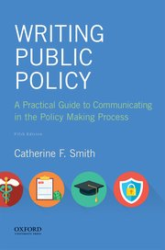  Catherine F. Smith  Writing Public Policy: A Practical Guide to Communicating in the Policy Making Process  Oxford University Press, 5th ed., 2018  ISBN 9780190854232 | Contact Information &  Regular & Substantive Contact  To communicate, please use Blackboard Messages  rather than UA Little Rock e-mail  - Bb Messages and “Ask Dr. Scranton” on the Discussion Board:  - I check the Bb message board every 18-36 hours, except on Sundays and holidays.  - You can also check for answers to classmates’ questions at “Ask Dr. Scranton” - often a question that occurs to you will also occur to a classmate, and my answer may already be posted.  - For emergencies, my cellphone is (501) 551-6524  - I post Announcements in Bb when I need to tell you about course updates, campus information you need to know, and unexpected situations.  - Office Hours: scheduled weekly and by appointment, before and after class Monday nights, 5:15-5:45pm and 8:40-9:00pm  - you can attend my scheduled office hours, or  - make an appointment: send me a Bb message with times you are available and we’ll set up an appointment by phone, Zoom or on campus.  - Your success is important to me. Regular communication contributes to success: don’t wait until a problem develops; instead, get in touch as soon as you need my assistance or have a question.

Course Description and Learning Objectives

Writing for Public Policy takes a technical writing approach to public policy making in a democracy, focusing on written and oral communication genres used in institutional and political processes. In this course, graduate students learn a general method for planning, producing and critically analyzing communications in a variety of real-life public policy contexts and situations.

This course is ideal for students preparing for careers in politics, government, public relations, law, public policy, journalism, social work, public health, or in any role related to public affairs. We will cover various public police during the semester, so you will be able to read and write about policies that you learn about in other MPA classes, as illustrated in this concept map, “types of public policy.”

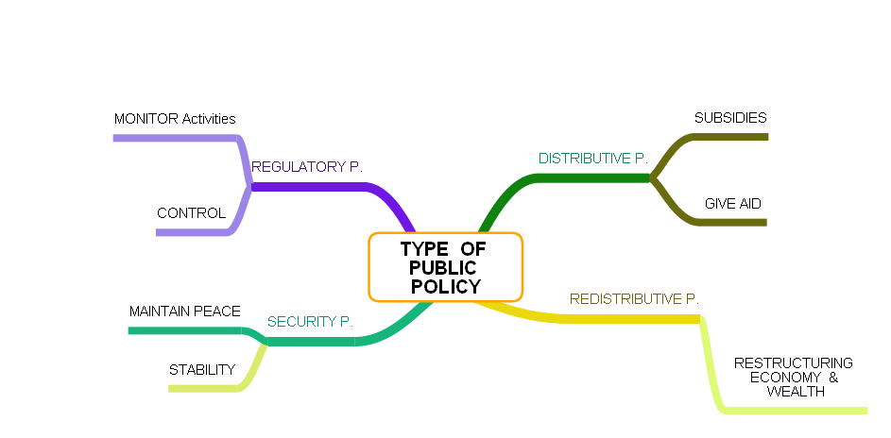

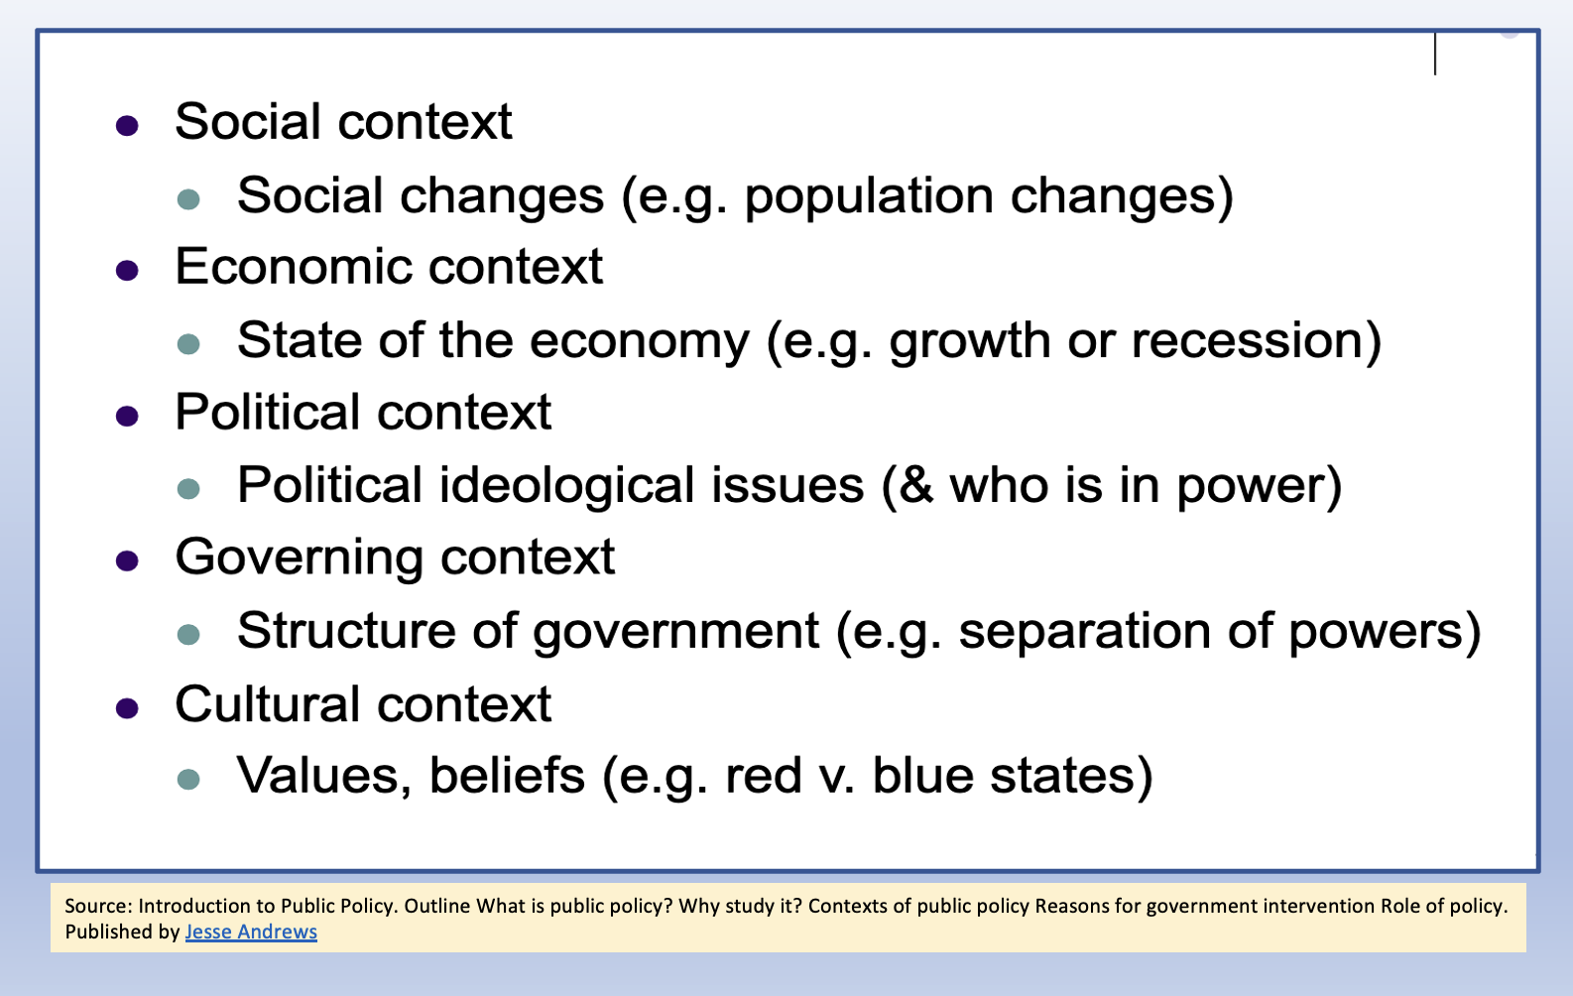
This course builds upon what you already know about academic writing, particularly your skills in researching and analyzing issues, and adds the technical writing skills you need to effectively communicate as a public administration professional. You will practice writing short documents like one-page memos, resolutions and press releases, and longer documents: public comments on federal regulations, policy briefs and position papers on issues, and technical policy reports. Students learn to evaluate long technical reports, legislative histories, and witness testimony before public agencies and legislatures and develop skills in writing for audiences with different needs, discourse analysis, and framing.

We will cover various public policy topics during the semester, including policing, service delivery (Covid-19 vaccines and infrastructure), federal and state regulations, and economic recovery.

This course builds upon what you already know about the social, economic, political, governing and cultural contexts within which public policymakers and the public operate, and upon what you already know about the policy making process.
Our special emphasis upon technical writing hones your policy writing skills, whether these relate to your present occupation or your next job.
Like other PADM courses, we pay particular attention to the contexts of contemporary public administration, the role of public administration professionals in the policy process, and accountability and ethical behavior of administrators and advocates.
Concerning ethics, our emphasis will be on writing that is accurate, based on credible evidence, and responsible, as well as being lucid, concise and audience-appropriate.

MPA Learning Objectives

In terms of MPA Program learning objectives, Writing for Public Policy emphasizes Communication Skills:
“Students will improve their written and oral communication skills that are essential for effective public administrators to communicate and interact productively with a diverse and changing workforce and citizenry.”
Professional policy communication differs from academic writing because of the reader you are addressing is a very busy administrator or official who needs a clear, concise message from you. That is why I think of this course as a bridge toward professional writing in a variety of workplaces, both in and outside of government.
During the semester you will read and critique writing samples in Smith’s textbook that were produced by citizen advocates, administrators, outside experts, and a variety of public officials. While our emphasis is primarily on written communication, you will critique an oral policy presentation and also record an oral presentation of your own. For each week in the semester, we discuss specific learning goals that relate to the readings and writing assignments for the week.
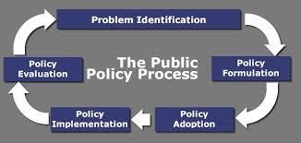
This course pays attention to policy writing created by all of the actors in the policy process: those inside of government – elected officials, appointees, and civil servants - and those outside of government – individuals as members of the public, policy advocates, groups and their representatives, and experts in think tanks and professional associations. In terms of the policy process, our focus is on how information — provided through written and oral communications —shapes policy choices at every stage rather than on details of the decision-making process itself.
By the end of the semester, you will have a portfolio of professional writing products that exemplify your policy writing skills in general and applications to specific policy writing genres.

Classwork Expectations and Goals

- Students will read, analyze, and write about a variety of policy documents: press releases and transcripts of press conferences, federal regulations, congressional witness testimony, professional/technical reports, and policy memos that document the nature and consequences of public problems.
- Students will improve and diversify their technical writing skills through genre-based writing formats and these techniques: framing, rhetorical awareness, policy discourse awareness, and understanding audiences.
- Students will distinguish between “bad” and “good” writing for various audiences.
- Students will contribute to their learning by participating actively and responsibly, reflecting on their learning, and submitting completed assignments on time.

Course Requirements

Required Reading
  - Catherine F. Smith, Writing Public Policy: A Practical Guide to Communicating in the Policy-Making Process (Oxford University Press, 5th ed., 2018); ISBN 9780190854232.
  - Various technical papers, reports, and documents in Blackboard, uploaded as .pdf files or via links to websites

Format and Required Technology, Writing and Participation and Mask Requirements

  - UA Little Rock requires that students, faculty, staff, and guests, regardless of vaccination status, in indoor public settings where physical distance cannot be assured in accordance with CDC guidance, wear a face mask. Reasonable exceptions may be permitted for certain settings and activities that follow guidance established by public health agencies and/or by external governing bodies such as athletics conferences and the NCAA.
  - To ensure face masks remain on in classroom settings, no food or drinks may be consumed in classroom settings. A cloth face covering, disposable face mask, or similar face covering that covers the mouth and the nose as recommended by the CDC is required and may be used as a face mask. A face shield may also be worn, but will not serve as a substitute for a face mask.
  - Format for campus-based synchronous classes: Our regular classroom is RH 118, a “smart classroom,” computers are available to use during class; if you prefer to use your laptop, bring that to class every week. Weekly meetings are from 6:00-8:40 pm, usually on Monday night.
  - Format for online hyflex classes: We meet synchronously on Monday from 6:30-7:30 pm, CST, using Zoom. I hold regular office hours from 6:00-6:25 pm and 7:30-8:00 on Mondays, before and after our synchronous class meeting. I provide asynchronous recordings explaining our writing assignments and inviting your questions and feedback about the required readings and guidelines for each genre-based policy writing assignment.
  - Virtual Protocol: If circumstances arise that prevent us from meeting at our regularly scheduled time and location, I will send an announcement out through Blackboard with a virtual classroom link where we will convene in the interim.
  - Completing weekly writing assignments: these include Blackboard-based discussions of Smith’s chapters and sample documents, provided in her textbook and online
    - Note: policy writing assignment (see pp.5-7) must be finished by the end of the week; Sunday, end of day is the weekly deadline. These 100-point assignments cannot be made up; it’s best to plan on completing these assignments by Friday or Saturday night, just in case something unexpected occurs on Sunday. I strongly recommend that you get started on your policy writing assignments at the beginning of the week.
    - Note: pre-class assignments to be completed before class are designed to create content for classmates to read and discuss during our synchronous class. These assignments must be posted in Bb before class. These assignments cannot be made up. We have pre-class writing assignments almost every week to kick-start our discussion of Smith’s chapters and orient you toward the week’s technical document reading and the policy writing assignments.
    - Note: to succeed in this class you must read assigned material and create discussion postings that are responsive to assignment instructions.
    - Note: I cannot grade assignments I cannot open; save using either a .pdf, .pages, or a .docx format; when in doubt, convert your text into a .pdf. Always keep a file of your assignments in case you need to re-submit.
  - Completing two reflective surveys on your learning and feedback about the class
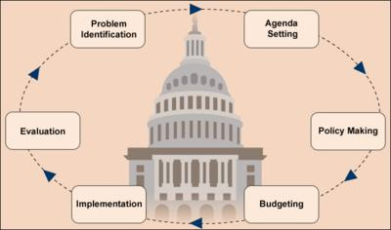
  - Posting your revised writing assignments in a Portfolio for MPA assessment; creating your own Google Docs folder, shared with Dr. Scranton, to be shared with Dr. Stevenson after the semester.

Course Structure

Following a start-up week with orientation assignments, the course will cover the topics listed in the table of contents of the Smith’s Writing Public Policy.

The first two chapters focus on language and policy communications; the next two chapters review stages of the policy process; the remaining chapters focus on genres of policy writing.

Chapters in Smith | Dr. Scranton’s explanations and your policy writing assignments, deadline for submission is Sunday, end of day
1. Public Policy is Language | Policy as words in action and aspects of technical language in policy writing; review of what public means
2. Communicating in Policy Making | Review of the Policy Making Process and kinds of communication that are typical of each stage in the process; actors who communicate with each other (elected officials, administrative officials, stakeholders, general public and interest groups).  Writing assignment: compare and contrast theformat, evidence and analysis in the 1967 Kerner Commission Report (National Commission on Civil Disorders) and the 2917 Department of Justice Investigation of the Chicago Police Department, as exemplars of task force reports and White Papers
3. Definition: Frame the Problem | Significance of language used during the problem definition stage of the policy process: understanding and analyzing frames and how language at this stage shapes choices available in subsequent stages of the policy process:  Writing assignments: “find the frame” in senators and witnesses statements at a congressional hearing and in confirmation hearing testimony by Supreme Court nominees and witnesses
4. Evaluation: Analyze and Advise | Characteristics of policy evaluation and the evaluation stage of the policy process; feedback, oversight, and technical reports (that analyze and advise) as a writing genre.  Writing Assignment: 2-page Memo to Governor of Virginia about 2018 election outcome and the state’s Vote Counting Handbook
5. Legislative History: Know the Record | How to read and write a legislative history as a writing genre; role of Congress in the policy process and how policies evolve over time; approval stage of the policy process.  Writing Assignment: locate online and write an evaluation of a legislative history
6. Position Paper: Know the Arguments | How to read and write a position paper as a writing genre; kind of arguments, use of evidence - textual and visual; how to evaluate arguments during formulation, legitimation and implementation stages of the policy process.  Writing Assignment: based on the Kerner Commission report or the DOJ Report on Chicago Policing, write a 5-page position paper, articulating and advocating a recommendation for a policy problem identified in the report.  Oral Report: make a professional oral report on your recommendation.
7. Brief, Opinion, Resolution: Inform Policy Makers | Three short policy writing genres: issue brief, opinion writing, press releases, and resolutions; how to read and write these genres; how to write what busy policy makers need to know and in ways they are likely to read  Writing Assignments: 1) write a 1-page issue brief or press release about the policy problem your wrote about last week; 2) select an interest group and write a 2-page evaluation (based on Smith’s standards) of the policy resolutions it posts online.
8. Testimony: Witness in a Public Hearing | Writing and delivering testimony as a policy genre; what makes an effective witness; types of hearings and varieties of testimony styles.  Writing Assignment: Select a recent nominee to the US Supreme Court, watch their confirmation hearing, and write a 4-page evaluation of their testimony and responses to Senators’ questions, with specific examples of more and less effective communication.
9. Public Comment: Influence Administration | How to read and write a public comment as a policy genre; federal regulations and comment procedures; how to locate comment announcements and file comments.  Writing Assignment: in the Federal Register, locate a proposed regulation that is “open” for public comment; write a 2-page comment that you could submit to the federal agency for input.
10. Conclusion: Practical Ethics for Policy Communication | Ethical standards for PA professionals
Appendix: Writing Clearly | Useful review and suggestions on professional writing

Assignments and Grading Policies
To pass the course, you must satisfactorily complete all the following requirements; this means that you should not plan to omit any assignments except for two pre-class writing assignments. I do not curve grades, and we do not have any extra credit work.

Assignments* | Points Available | Grading Scale
Start-Up Assignments - Code of Conduct and Plagiarism Tutorial and Test | 50 | A = 1080-1200
Pre-class Writing Assignments 8 out of 10 @ 25 points | 200 | B = 960-1079
Policy Writing Assignments - 8 @ 100 points | 800 | C = 840-959
Portfolio of Revised Policy Writing Assignments | 100 | D = 720-839
2 Reflective Learning Surveys @ 25 points | 50 | F = 719 and below
Total points | 1200

*For all of our assignments, I provide detailed written guidelines along with matching grading rubrics that you can review in Bb at MyGrades. You will see exactly what is required in terms of reading and writing, use of sources, and levels of proficiency (the difference between full points and fewer points earned).

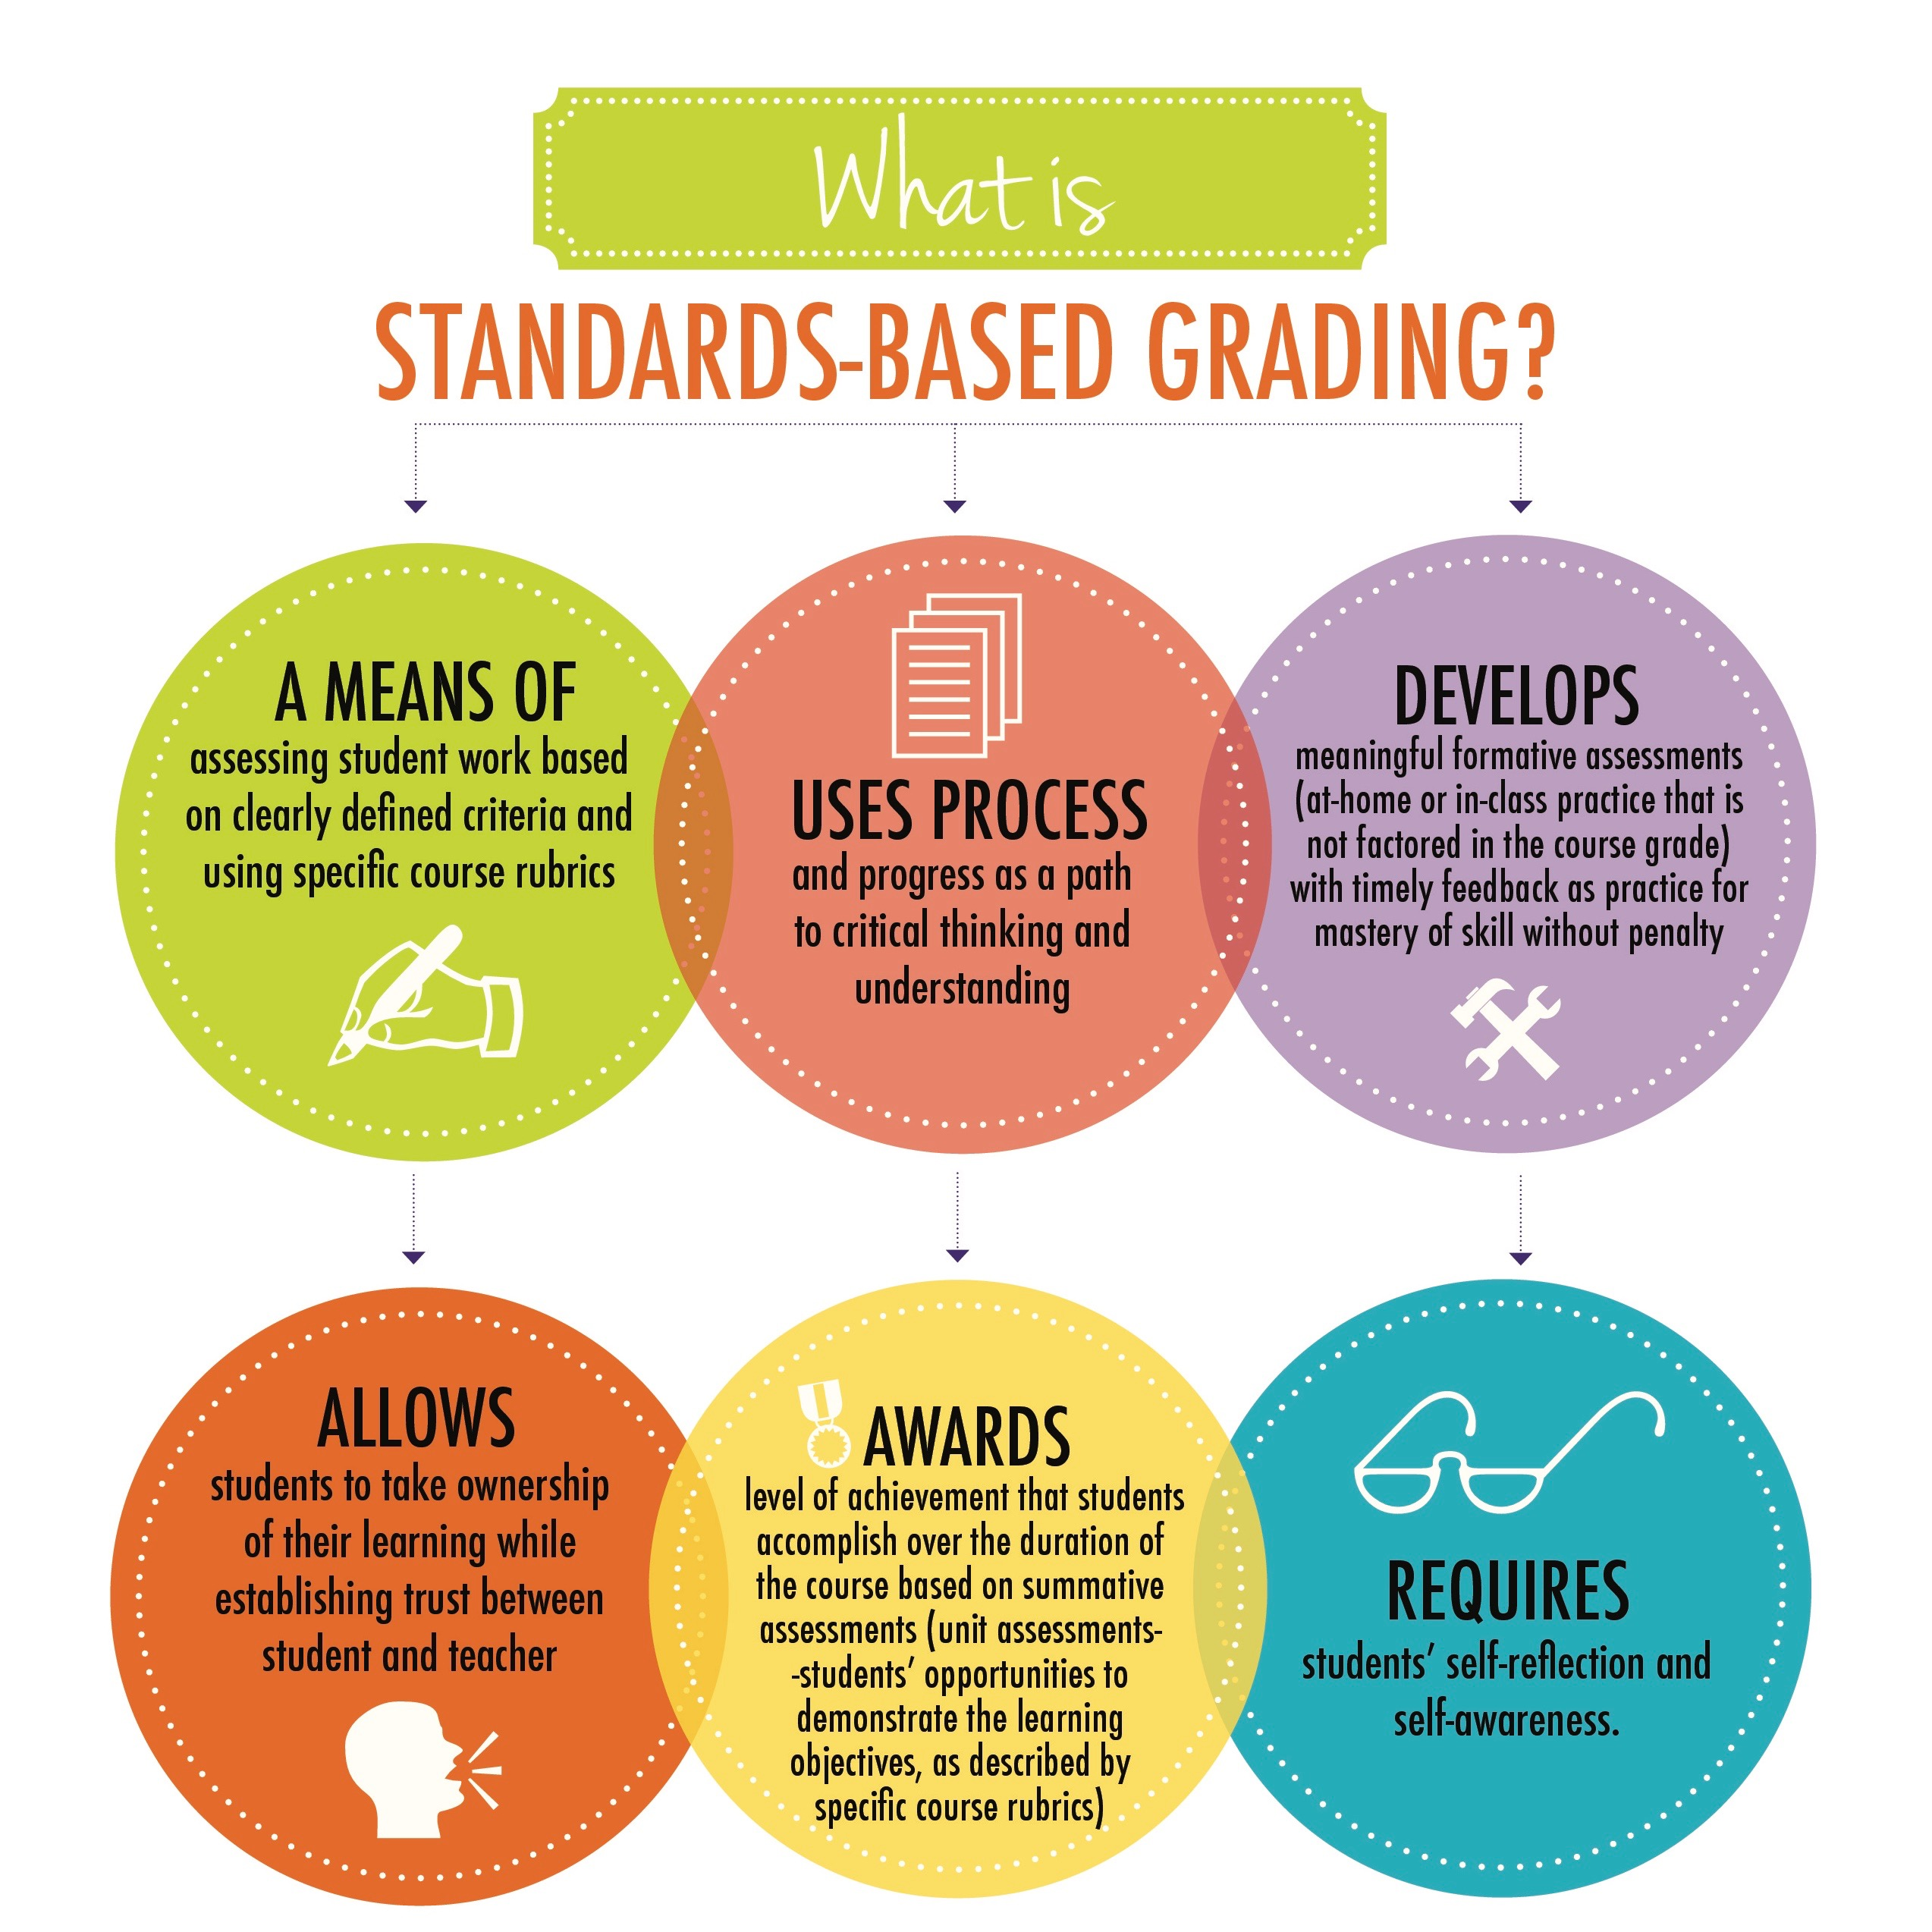
About proficiency/mastery/standards-based grading

I expect most students to perform at “proficiency” or “high-competency” most of the time; I do not expect to see much “average” or “competent” work, yet I will not hesitate to provide an honest appraisal of your performance.

I understand that assignment guidelines may seem clear, in principle, before you start processing readings and writing. Because we use a “flipped classroom” format, meaning that we begin working on assignments during a writing workshop prior to the due date, I address your concerns as you start writing. For this process to work, you must review those materials prior to the workshop, whether we are meeting synchronously or asynchronously. Especially in an asynchronous format, you are responsible for understanding the material and assignment instructions. While we begin this process in our synchronous weekly session, questions may not occur to you until you sit down to process the reading and begin writing. It’s vital for you to communicate with me immediately if you have questions or need clarification.

In the Weekly Schedule, I distinguish between materials to process prior to class — the materials you process before the week begins and discuss with me and your classmates at the beginning of the week, versus new material that we being processing in class and during the week.For some material, we spend more than one class session and do more than one policy writing assignment.

Revision is an important component of standards-based grading. You will revise your genre writing assignments and upload those into your Google Docs folder for MPA Assessment. Our weekly policy writing assignments provide formative assessment — I provide individual feedback on your mastery of content and writing skills. Sometimes, I add additional material or additional pre-class writing or different pre-class writing when the class’s formative assessments show that we have not reached proficiency for the analytical skill or writing genre. Your collection of edited portfolio of genre writing assignments constitutes artifacts for my summative assessment of your semester’s work, and I share your Google Docs Portfolios with the MPA Assessment Committee.

Your responsibilities for your success

If you have questions between classes about assignment instructions or the grading rubric, please post those at “Ask Dr. Scranton” or send me a Bb message. It is vital for you take responsibility for being confident that you are on the right track with your work. And, in addition to our weekly policy writing assignments, you may have questions about Smith’s chapters, her writing instructions, and our other reading assignments. To promote your success, just as you would raise a hand in a campus class or visit with your professor before/after class, you will use “Ask Dr. Scranton” to communicate with me between classes. I am also available during regular office hours and via Bb messages.

I can troubleshoot Bb assignments and content that I create, but you need to use Bb Student Support for issues relating to your computer’s settings, Blackboard issues, and your internet connection.
When in doubt, contact me! I often post an answer announcement to the class when I receive a question, so you should regularly check “Ask Dr. Scranton” to see if someone has already asked your question.

Course Policies

Attendance, Participation, and Late Work

Regular attendance, on campus or virtually, if the Covid situation worsens, is necessary to succeed in this class. Even if you must miss a class period, you should submit your writing assignment on time.
I do not take attendance; instead, your written weekly assignments (1-2 per week) count as your participation. Ideally, assignments are handed in on time, according to the class deadline in the Weekly Schedule, because we have new assignments that build upon work completed during previous classes.

Incompletes

I only accept a request for an incomplete if a severe emergency occurs during the last week of class that prevents you from completing the semester. I can only grant a request for an Incomplete to students who: a) have completed (and passed!) the required work up to the point the emergency occurs, b) have a legitimate, documented emergency, and c) have proposed a reasonable plan, with a timetable, for completion of the required work within 15 days.

Syllabus Changes and Bb Problems

Although I make every effort to present accurate, complete information, this syllabus is subject to change, especially during the Covid-19 pandemic.
- If a schedule or assignment change is necessary, I will notify the class in a Bb announcement.
- If we experience a Bb server interruption during the 24 hours prior to a deadline, I will extend the deadline by 24 hours. Usually we will receive an email about a Bb outage; depending upon the length and severity of the problem, we may have Bb restored in a few hours or a day or longer. We will adapt to that situation.
- If you experience a Bb connection problem, it is your responsibility to contact Bb Student Support. Remember that I am a SPA professor, not a computer support technician!

I do want to hear from you if you find an error in the syllabus or assignment so that I can fix that problem!

Classroom Etiquette/Netiquette

For our classroom to be a safe learning space, we must adhere to these values: respect for others and their views, civility, professionalism, and willingness to disagree agreeably. You can count on me as your professor to maintain a supportive and appropriate learning environment. In our Start-Up Assignments we have a handout on Netiquette that clarifies appropriate vs. inappropriate communication online; the same standards apply in person.
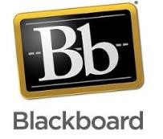

Computer Skills and Requirements

We use Blackboard as the “file cabinet” for our course, to submit assignments, and also as our messaging system, rather than UALR email. Students must possess basic computer skills and to have reliable internet access and a computer. If you need a refresher on using Bb, take the Blackboard Orientation course listed in your My Courses during the Start-Up week. This online tutorial course shows how to navigate a course in Blackboard and how to tools like the discussion board, how to submit assignments, etc.
While some Blackboard (Bb) features are available with digital devices like smartphones and tablets, writing assignments are not. In our Start-Up Assignments, I post a list of Bb functions that are available for various digital devices as well as Bb Student Support advice for taking online classes.
For virtual class meetings and my online office hours, we will use Zoom; I will post Zoom invitations in Bb. Remember that Zoom updates frequently, so if you encounter Zoom problems, check for updates at https://zoom.us/.

University Policies

Course Accessibility

Your success in this class is important to me, and it is the policy and practice of the University of Arkansas at Little Rock to create inclusive learning environments consistent with federal and state law. If you have a documented disability (or need to have a disability documented) and need an accommodation, please contact me privately as soon as possible, so that we can discuss with the Disability Resource Center (DRC) how to meet your specific needs and the requirements of the course. The DRC offers resources and coordinates reasonable accommodations for students with disabilities. Reasonable accommodations are established through an interactive process among you, your instructor(s) and the DRC. Thus, if you have a disability, please contact me and/or the DRC at 501-569-3143 (V/TTY) or 501-683-7629 (VP). For more information, please visit the DRC website at www.ualr.edu/disability.

Academic Integrity

Anyone caught plagiarizing will be disciplined according the regulations and procedures contained in the UA Little Rock Student Handbook. A slideshow on violations of academic integrity, including plagiarism, is available at http://www.ualr.edu/copyright/articles/?ID=4.

We have two Start-Up Assignments that support this policy: 1) you will sign the UA Little Rock Code of Student Conduct, and 2) you will take a Plagiarism Tutorial and Test that explains how to paraphrase correctly and when/how to cite sources. For additional information, see the UA Little Rock Academic Integrity site: https://ualr.edu/deanofstudents/academic-integrity/.

Inclement Weather

During inclement weather, UA Little Rock will decide whether or not to close based on all available information. The UA Little Rock website, UA Little Rock email, the university’s main telephone number (501.569.3000), and the Rave campus alert notification system are the official means of communicating information concerning weather-related closings. When necessary, the university will announce a separate decision about canceling night classes (those classes starting at 4:20 p.m. or later) by 2 p.m., if possible.

Weather and road conditions vary from place to place. Employees and students are expected to exercise good judgment regarding the safety of travel when road conditions are affected by the weather. If I cannot come to campus, I will post a Bb Announcement, and we will hold a class via Bb Collaborate or Zoom instead.

Student Complaints

Students are encouraged to seek informal resolution at the department level when possible. After exhausting the department or informal complaint process, students may file a formal complaint with the university. To file a formal complaint, please complete this form with as much information as possible. Student complaints may be submitted anonymously; however, including your contact information will assist the university in responding to your complaint.
The policy for student complaints can be found here.
This form does not apply to complaints regarding the following issues:
- Title IX
- Grade Appeals
- Parking Violations
- ADA-related Discrimination
- Other issues where a separate policy and procedure for resolution are already approved.

Non-Discrimination Policy

UA Little Rock adheres to a policy that enables all individuals, regardless of race, color, gender, national origin, age, sexual orientation, veteran’s status, or disability to work and study in an environment unfettered by discriminatory behavior or acts. Harassment of an individual or group will not be condoned and any person – student, faculty, or staff member – who violates this policy will be subject to disciplinary action. Any person who believes they have been discriminated against should contact the Human Resources Office to obtain assistance and information concerning the filing of complaints, (501) 569-3180.

Harassment which is considered discriminatory, includes actions or conduct (verbal, graphic, gestural, or written) directed against any person or group with the intent to demean or create a hostile or threatening environment. It is not the intent of this policy to infringe upon or limit educational, scholarly, or artistic expression. At the same time the University prohibits discriminatory practices, it promotes equal opportunity through affirmative action.

Nondiscriminatory affirmative action, equal opportunity policies apply to: recruitment, hiring, job classification and placement, work conditions, promotional opportunities, demotions/transfers, terminations, training, compensation, choice of contractors and suppliers of goods and services, educational opportunities, disciplinary action, recreational and social activities, use of facilities, housing, and University sponsored programs.

UA Little Rock Student Resources

- Blackboard Support (also see link in Blackboard navigation bar) o The Blackboard Support website was designed to assist students with information about the Blackboard system including tutorials, helpful resources, downloads, and answers to their frequently asked questions. In addition to the website, students can call the Bb office during business hours; you can also find help within the Blackboard system using the Help tab or through their social media outlets on Facebook and Twitter. You can connect to Blackboard Help at Net ID login page or directly from ualr.edu/blackboard.
  - Your courses in Blackboard also have an online “help” link.
- IT Services
  - For technical support with other UALR systems, including logging into Blackboard, BOSS, or your UALR email, please contact the IT Help Desk at ualr.edu/itservices or by calling 501.916.3011.
  - Business hours are Monday through Thursday from 7:00 am to 6:00 pm, and on Fridays from 7:00 am to 5:00 pm.
- Ottenheimer Library
  - Ottenheimer Library collects, organizes, and provides access to information resources and library services that enrich and support the University’s research and teaching mission, foster intellectual development, and promote academic excellence.
  - Visit the Ottenheimer Library Website http://ualr.edu/library/ for information about the library and its collections, and view available services.
- Writing Lab: Visit the Writing Center http://ualr.edu/writingcenter for more information about the services they provide, their online submission guidelines, and virtual writing conferences.
- Communication Skills Center: The Communication Skill Center (CSC) is a resource devoted to helping campus and online students in the various stages of preparing a presentation. We help take the panic out of public speaking! Services include, but are not limited to, public speaking anxiety management, brainstorming, research, content organization, PowerPoint/Prezi design and integration, and providing presenters with helpful rehearsal feedback. The CSC will be offering online services during Fall 2020:
  - To schedule an online video call appointment, please use the following link: https://ualrcommunicationskillcenter.setmore.com/
  - To access the online chat, please use the following link (and be sure to log-in to your email): https://hangouts.google.com/group/ncmX9d991pbMAkV66
  - To request support via email, please send your request to the following address: communication.skill.center@gmail.com

Let’s have a great semester!
Dr. Scranton

