Workday Login: -

After completing the hiring process and paperwork, you will receive an email from Workday to login into your account. Below steps needs to be followed to complete the workday setup

- You can access to your workday account through My Apps
- Login using your UALR mail ID and password.

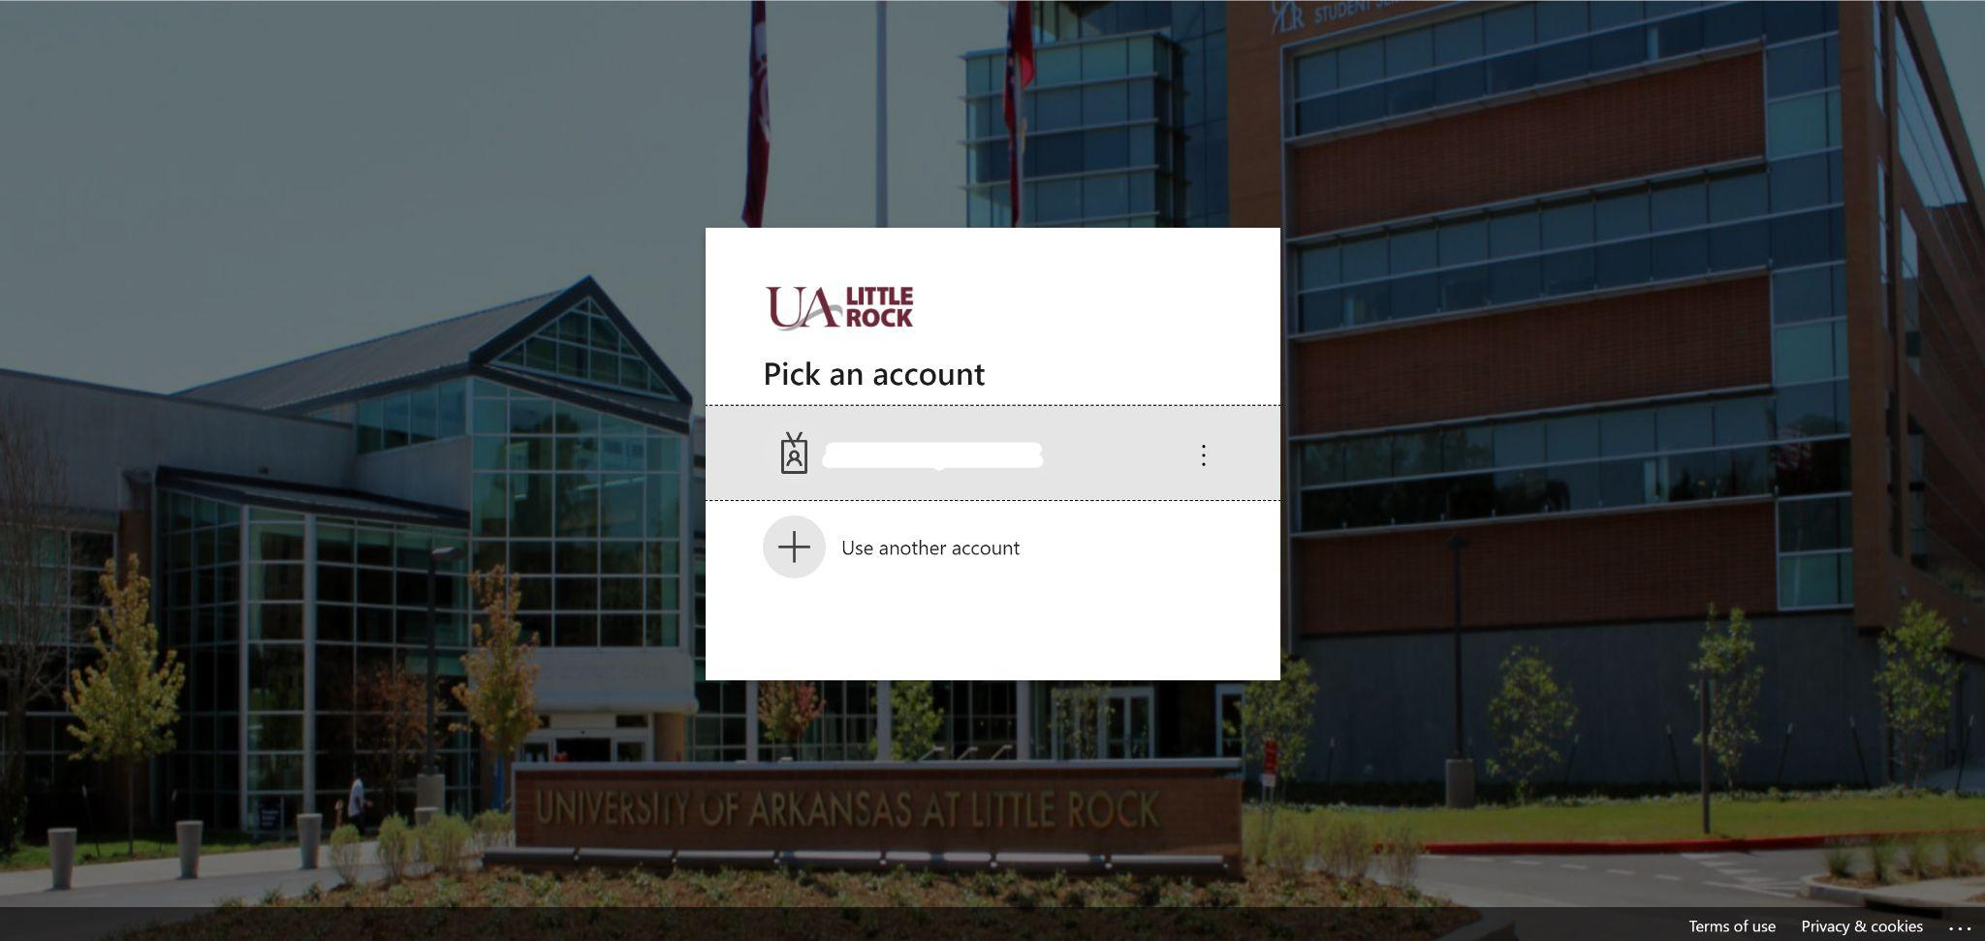
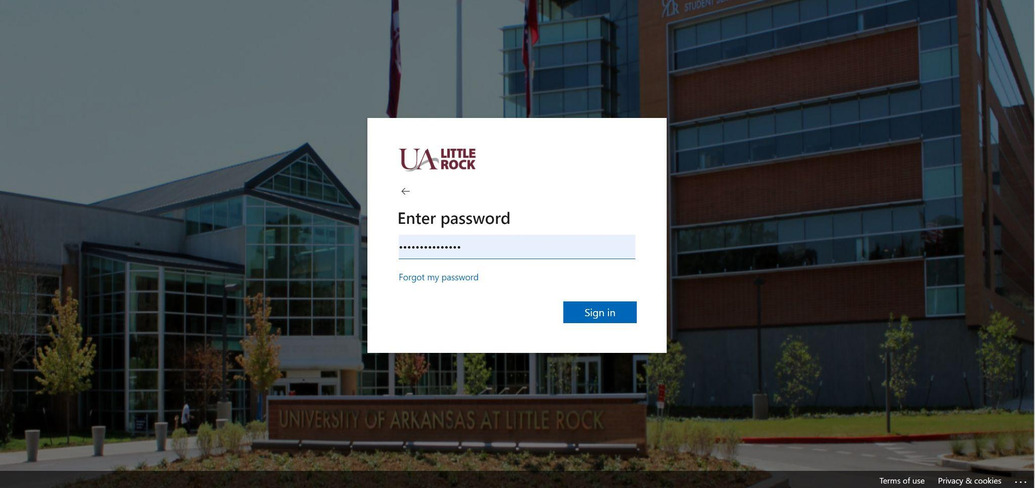
- Once you login, you will be asked to download the Microsoft Authenticator App.

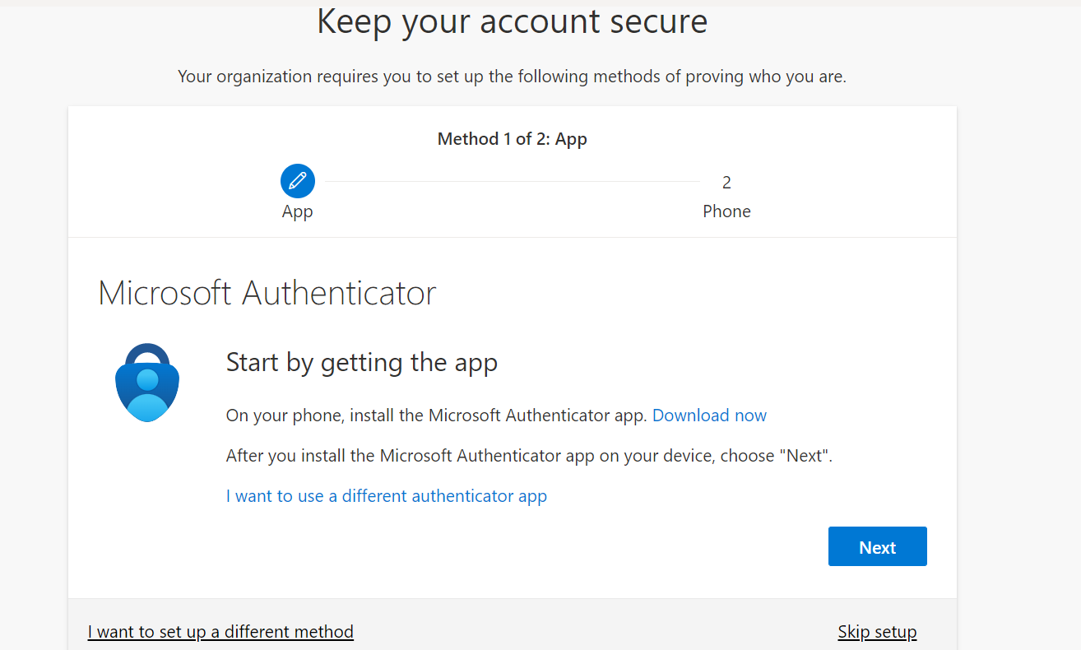

- Once you have downloaded the app, you can add your school account. You can either sign in or scan the QR code which will be shown on the screen

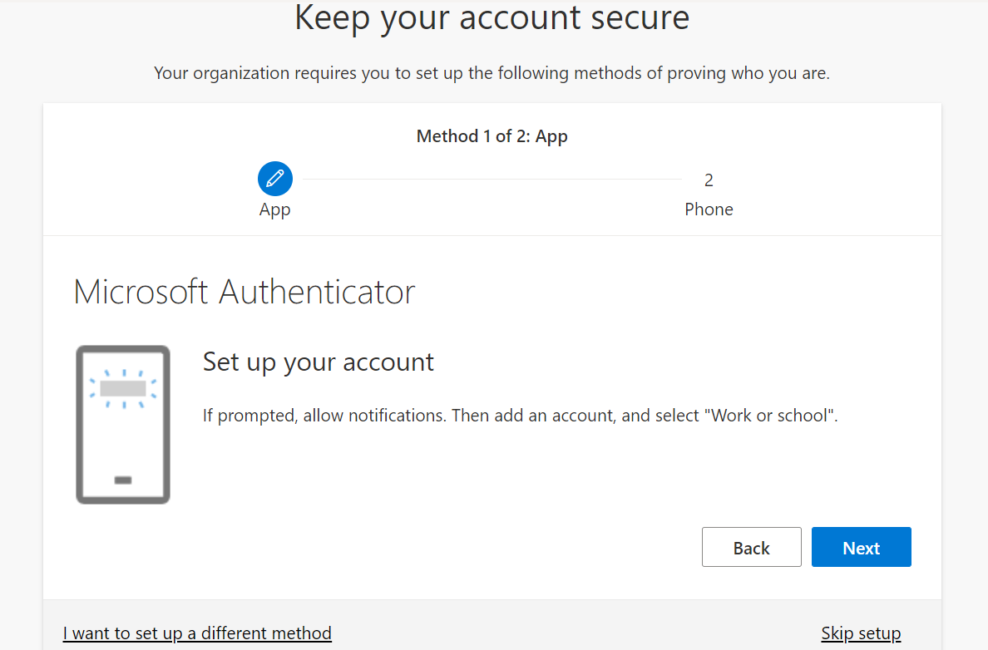

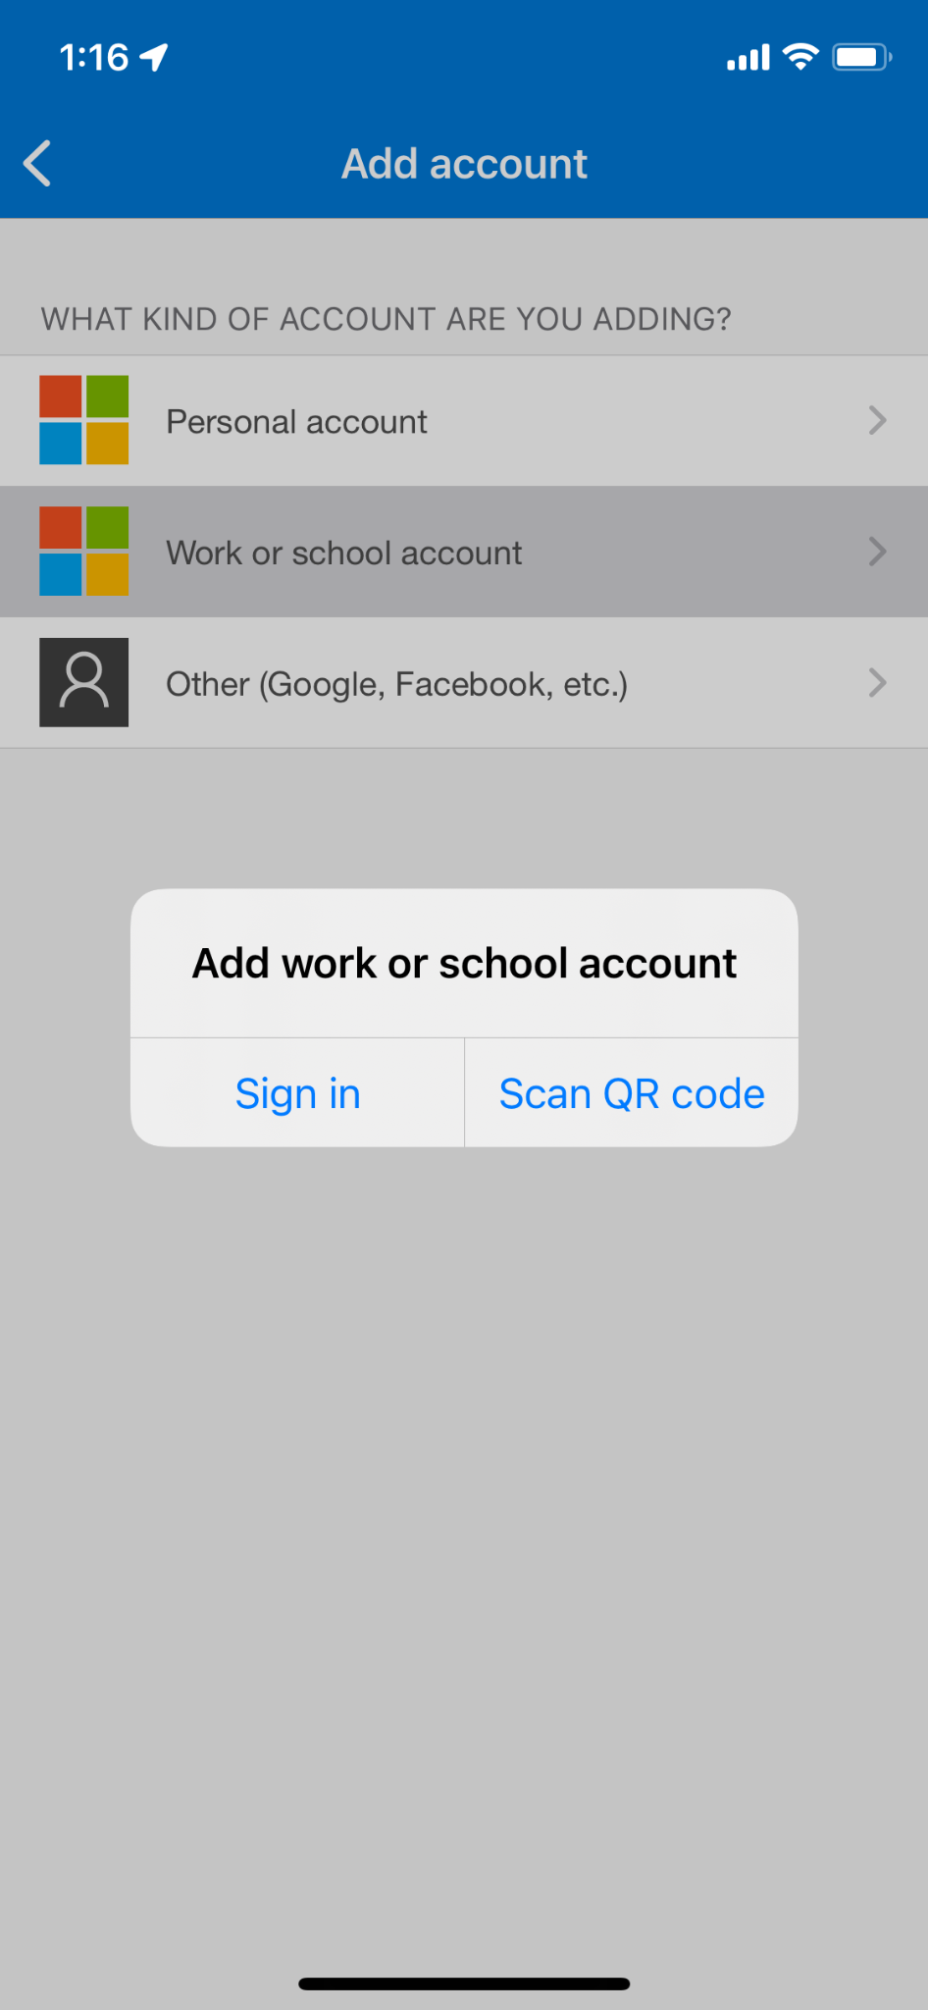

- Click next after scanning the QR code, students will then receive a message in the Authenticator app, press approve.
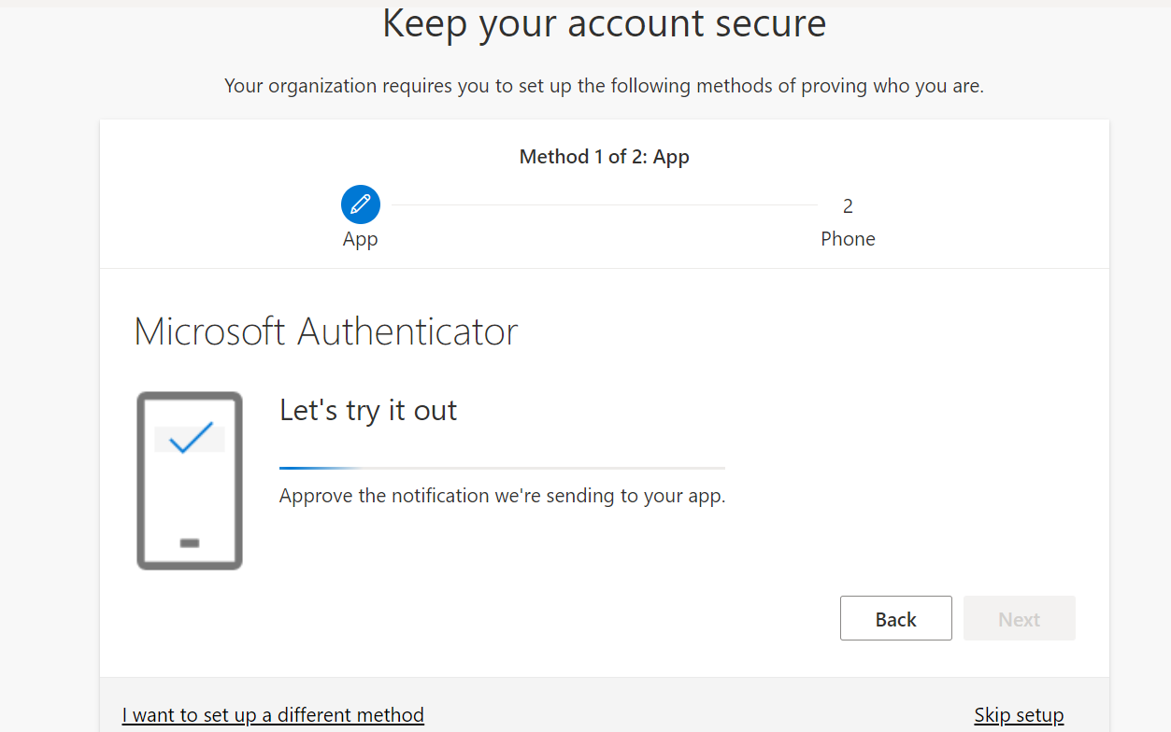
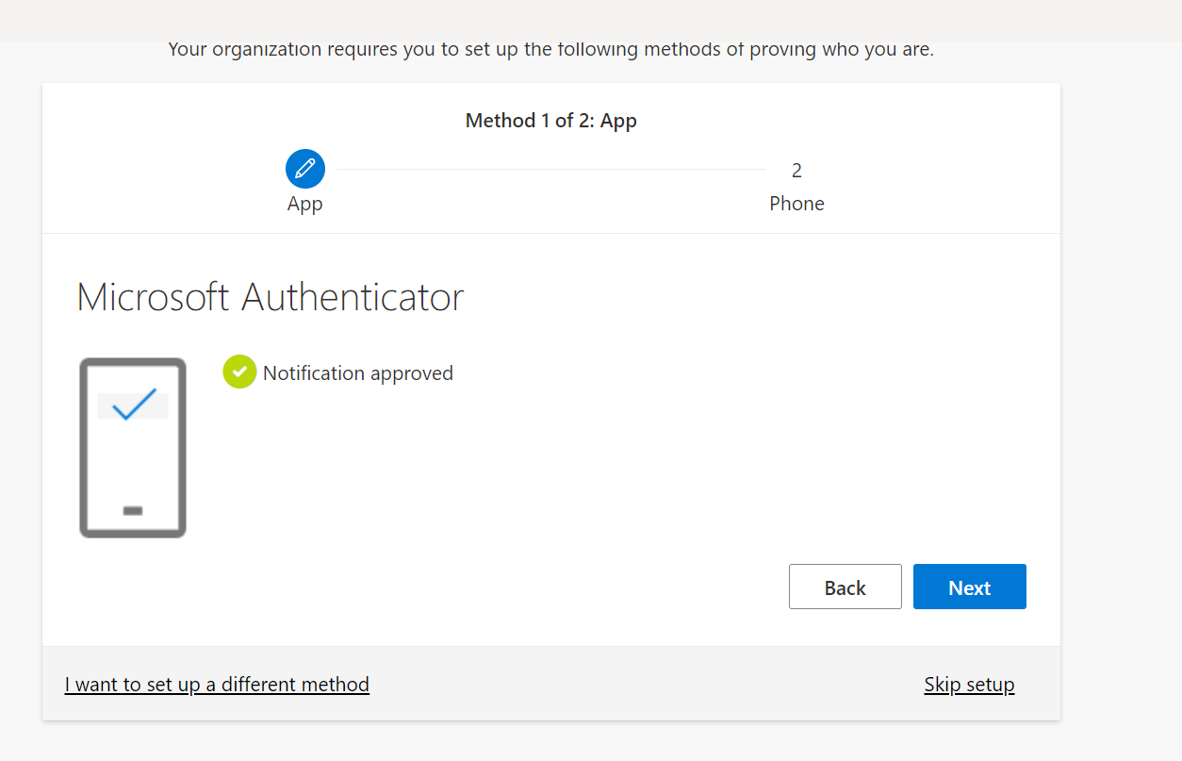

- Click on next to add your phone number for authentication

- Once the authentication setup is done, you can login now login into your workday account

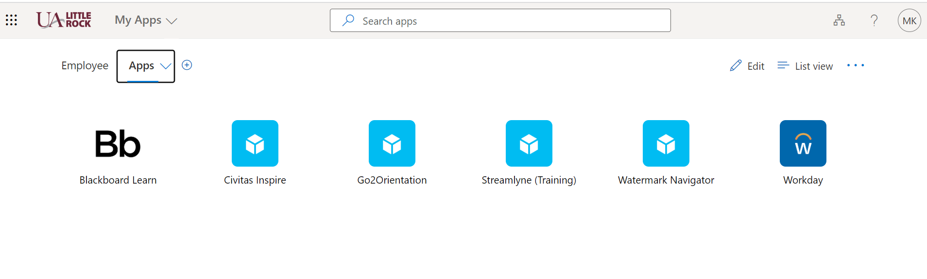

Onboarding Process

- Once you login into your account, you can now complete the onboarding process.

- To complete the onboarding process the student will click on the bell in the upper right-hand corner of the page. There will be notifications of needed items to complete. Students will need to go through each notification to confirm profile information, payment, benefit, and other information.

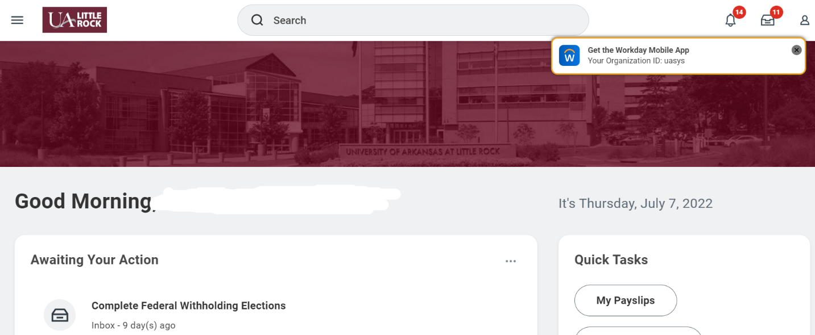

- Students need to complete all the awaiting task displayed on the profile.

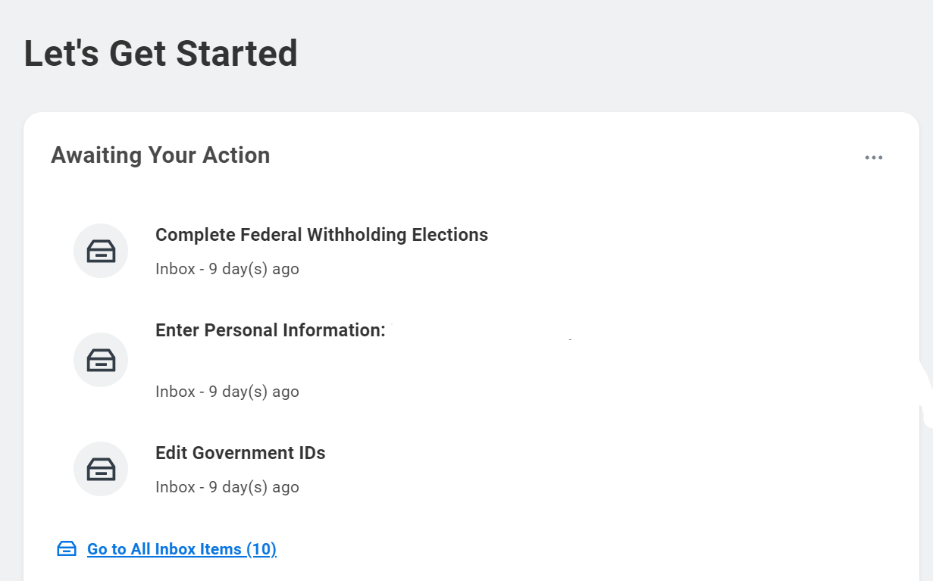

Any issues, while logging into workday account contact IT Services

